

**TCC6313/TCCF6313 CLOUD COMPUTING**

**PROJECT**

TRIMESTER OCTOBER/NOVEMBER 2530

|  |  |  |  |  |
| --- | --- | --- | --- | --- |
| **No.** | **Student ID** | **Student Name** | **Majoring** | **Signature** |
|  | 252UT254LM | TANG YUT HEE | AI |  |
|  | 252UT254LK | CHA AIK HONG | AI |  |
|  | 1231302326 | MEFTAH MOUNIB WASSIM | AI |  |
|  | 1221103206 | DERRICK CHUA PENG BOON | AI |  |

**Table of Contents**

Acknowledgement 4

Introduction 5

Introduction of Website 6

Phase 1 10

Phase 2 20

Phase 3 26

Phase 4 36

Reflection 44

References 46

Appendices 47

Rubrics 48

**Table of Figure**

Figure 1 Register page 6

Figure 2 Log in page 6

Figure 3 User dashboard 7

Figure 4 Create post page 7

*Figure 5 Profile page* 8

*Figure 6 Edit post page* 8

Figure 7 Delete confirmation page 9

Figure 8 Phase 1 Layout Diagram of the Network 10

Figure 9 VPC configuration page 11

Figure 10 Details of wonderland-vpc 12

Figure 11 Details of create wonderland-subnet-public10 13

Figure 12 Details of create wonderland-subnet-private10 13

Figure 13 Subnets Dashboard 14

Figure 14 Edit Private Subnets Associations 14

Figure 15 Edit Public Subnets Associations 15

Figure 16 Configuration of Security Group 16

Figure 17 GitHub repository 17

Figure 18 Configuration of instances 17

Figure 19 Configuration of user data 18

Figure 20 Details of wonderland web server 18

Figure 21 successful login to web 19

Figure 22 Phase 2 Layout Diagram of the Network 20

Figure 23 Configuration of DB security group 21

Figure 24 Configuration of DB subnet group 22

Figure 25 Information of wonderland-db 23

Figure 26 Configuration of wonderland-db 24

Figure 27 MySQL Database Dump Generated Using mysqldump 24

Figure 28 Create database in rds 24

Figure 29 Dump SQL 24

Figure 30 config.php(before) 25

Figure 31 config.php(after) 25

Figure 32 Databases list 25

Figure 33 Phase 3 Layout Diagram of the Network 26

Figure 34 Target group targetwonderland configuration (HTTP:80, VPC: wonderland-vpc) 28

Figure 35 Registered EC2 targets and health status for targetwonderland (Healthy) 28

Figure 36 Application Load Balancer wonderlandELB (Active) and DNS name 29

Figure 37 Application Load Balancer wonderlandELB showing associated security group 31

Figure 38 Inbound rules of ALB security group allowing HTTP traffic from the internet 31

Figure 39 EC2 security group allowing HTTP from ALB security group (restricts direct public access) 32

Figure 40 Application accessed via ALB DNS confirming end-to-end connectivity 33

Figure 41 RDS instance wonderland-db status and endpoint (used by EC2 application) 34

Figure 42 Phase 4 Layout Diagram of the Network 36

Figure 43 Create AMI 37

Figure 44 Create launch template 38

Figure 45 Instance type 38

Figure 46 Wonderland Security Group Firewall Settings 39

Figure 47 Enabling CloudWatch Monitoring 39

Figure 48 Creation of the Custom AMI 40

Figure 49 Configuration of the Launch Template 41

Figure 50 Creation of the Auto Scaling Group (ASG) 41

Figure 51 Definition of Dynamic Scaling Policies 42

Figure 52 Add Tags 43

Figure 53 Alarm Dashboard 44

Figure 54 Instance Auto Scalling 44

**Table of table**

Table 1 Target Group 28

Table 2 Application Load Balancer (ALB) 31

Table 3 ALB (wonderlandELB) 33

Table 4 Configuration of ASG (wonderland_AS) 44

# Acknowledgement

We would like to express our sincere gratitude to our lecturer, Dr. Sumendra Yogarayan, for his invaluable guidance, continuous support, and patience throughout the duration of this project. His technical insights and constructive feedback were instrumental in the successful design and implementation of our Student Management System architecture.

We would also like to thank him for providing the necessary resources and knowledge regarding AWS cloud infrastructure, which greatly assisted our team in navigating the complexities of the project, particularly in implementing Auto Scaling and Automated Monitoring.

Finally, we extend our thanks to our families and friends for their encouragement and understanding, which motivated us to work together and complete this assignment.

# Introduction

With the rapid development of cloud computing technology, more and more enterprises and individuals are choosing to deploy their websites and application systems in the cloud to improve system availability, flexibility, and scalability. The main goal of this project is to develop a simple dynamic website and deploy it on the Amazon Web Services (AWS) cloud platform, allowing us to experience the complete process from website development to cloud deployment.

The website developed in this project is a basic message board system, providing user registration and login functions. After successfully logging in, users can browse messages posted by other users and create new messages themselves. Each message only requires filling in a topic and content, making the operation simple and intuitive. In addition, the system also has a profile page, allowing users to manage their posted messages, including editing and deleting functions, thus implementing a basic content management mechanism.

Regarding system deployment, this project uses Amazon Web Services (AWS) as the cloud server platform and uses EC2 instances to set up the website server. Through the cloud infrastructure provided by AWS, the website can be accessed via public IP address or DNS name, establishing a connection between the website and the server. This project focuses not only on implementing website functionality but also on configuring the cloud environment and designing the network architecture, such as Virtual Private Cloud (VPC), subnets, and server accessibility.

Through this project, we believe we will gain a deeper understanding of the fundamental concepts of cloud computing, including the creation, management, and deployment processes of cloud resources. Simultaneously, this project teaches us how to migrate traditional web applications to a cloud environment and helps us understand the advantages of cloud computing in website hosting, system scalability, and high availability. Overall, this project combines web application development with AWS cloud computing technology, providing students with a complete and practical learning experience.

# Introduction of Website

This is a simple message board system. The system will allows users to register, log in, and manage messages. First-time users must register an account,the system will ask for a username and password.

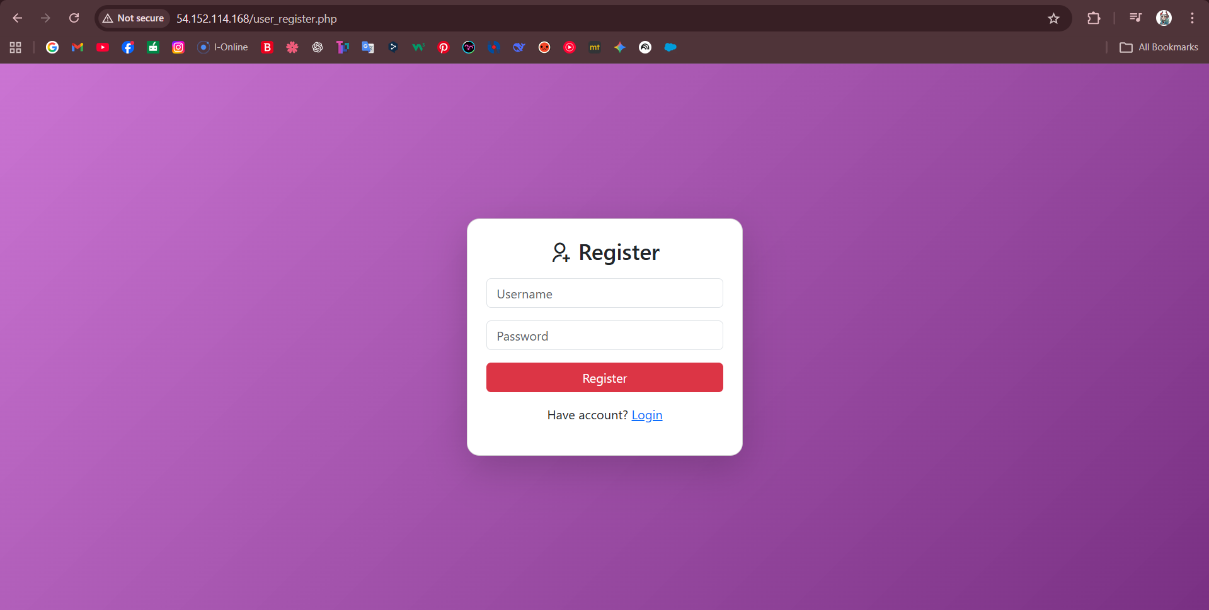

Figure 1 Register page

After successfully logging in, users can return to the login page and log in to their account to access the main page.

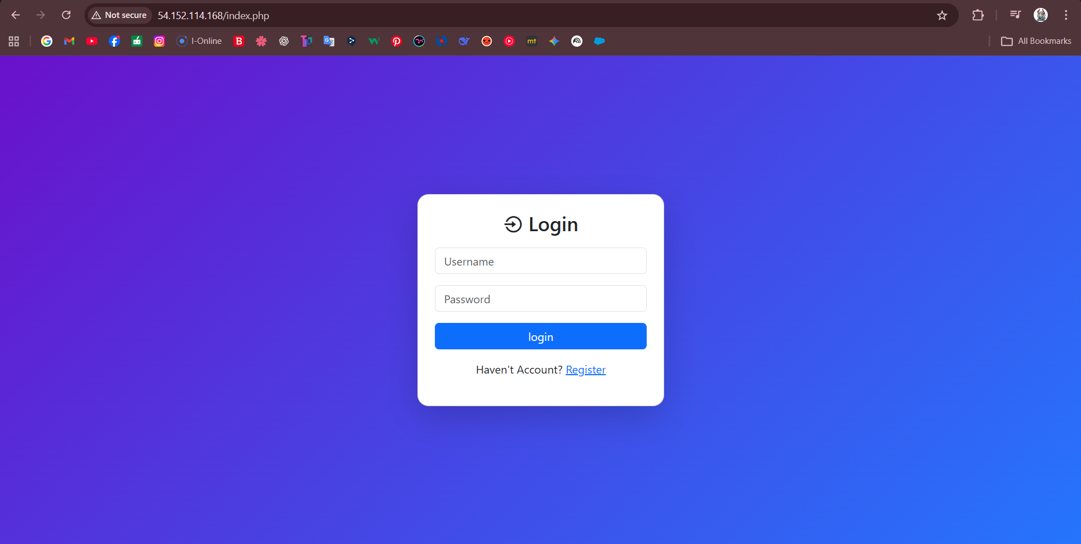

Figure 2 Log in page

After logging in, users will be taken to the user dashboard, where they can clearly see other users' comments. In the top left corner, there's a "create" button, allowing users to create their own comments. In the top right corner are "profile" and "logout" buttons.

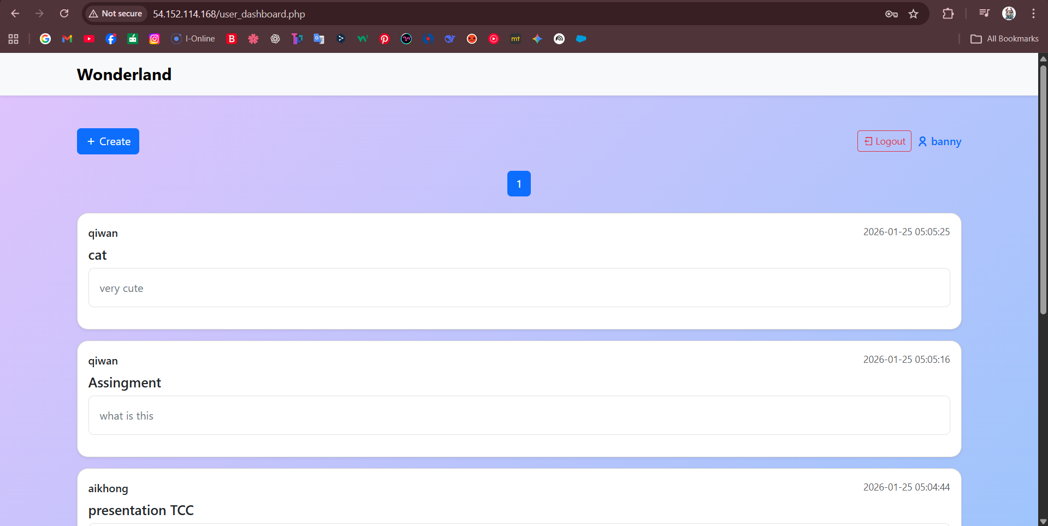

Figure 3 User dashboard

When a user presses the create button, they will be taken to the create post page, where they will be prompted to enter a title and description. After the user has finished entering the information, they can post it.

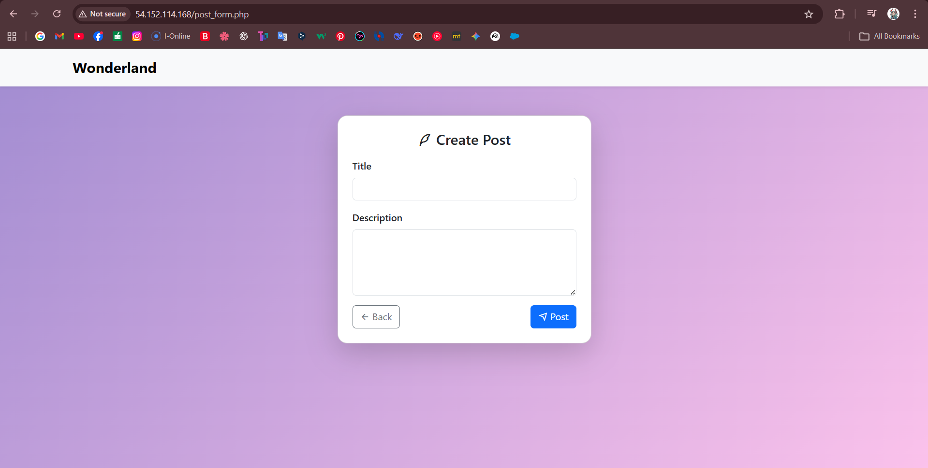

Figure 4 Create post page

When a user clicks their name in the upper right corner of the user dashboard, they will taken to the profile page. From here, they can see their comments and perform actions such as deleting or editing.

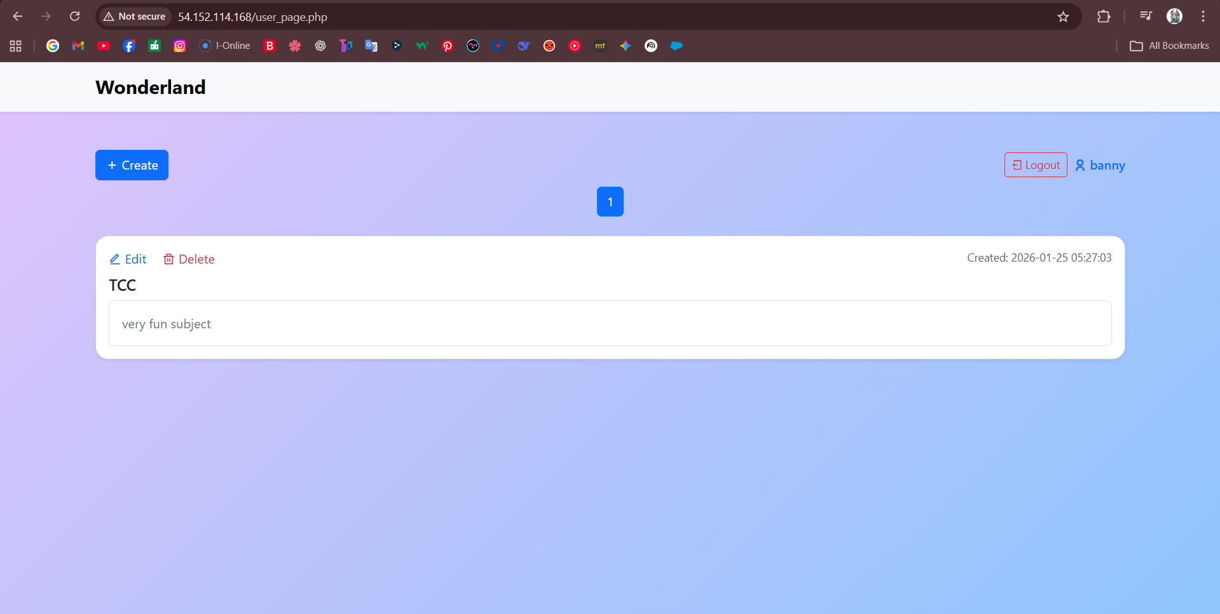

*Figure 5 Profile page*

When a user presses the edit button, they are taken to the edit page. This page allows the user to edit and update the comment.

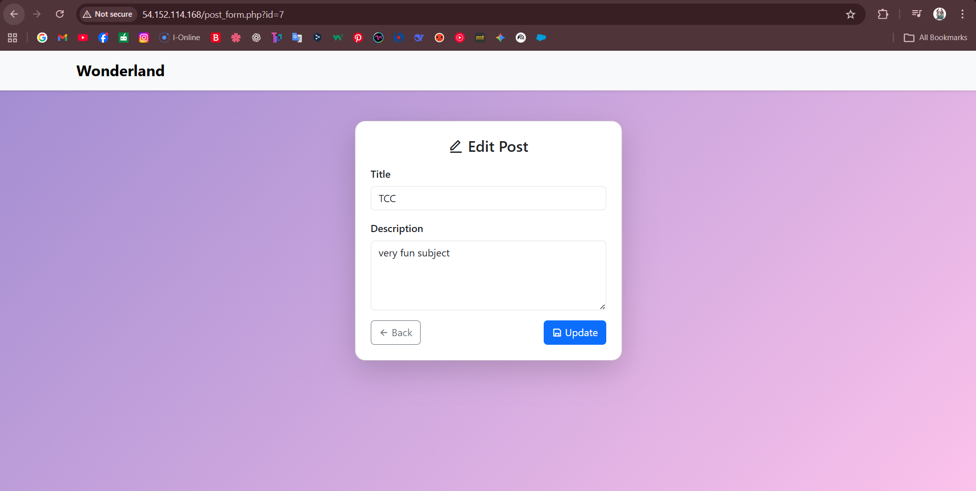

*Figure 6 Edit post page*

When the user presses delete, the system will ask again to ensure that the user really wants to delete the information.

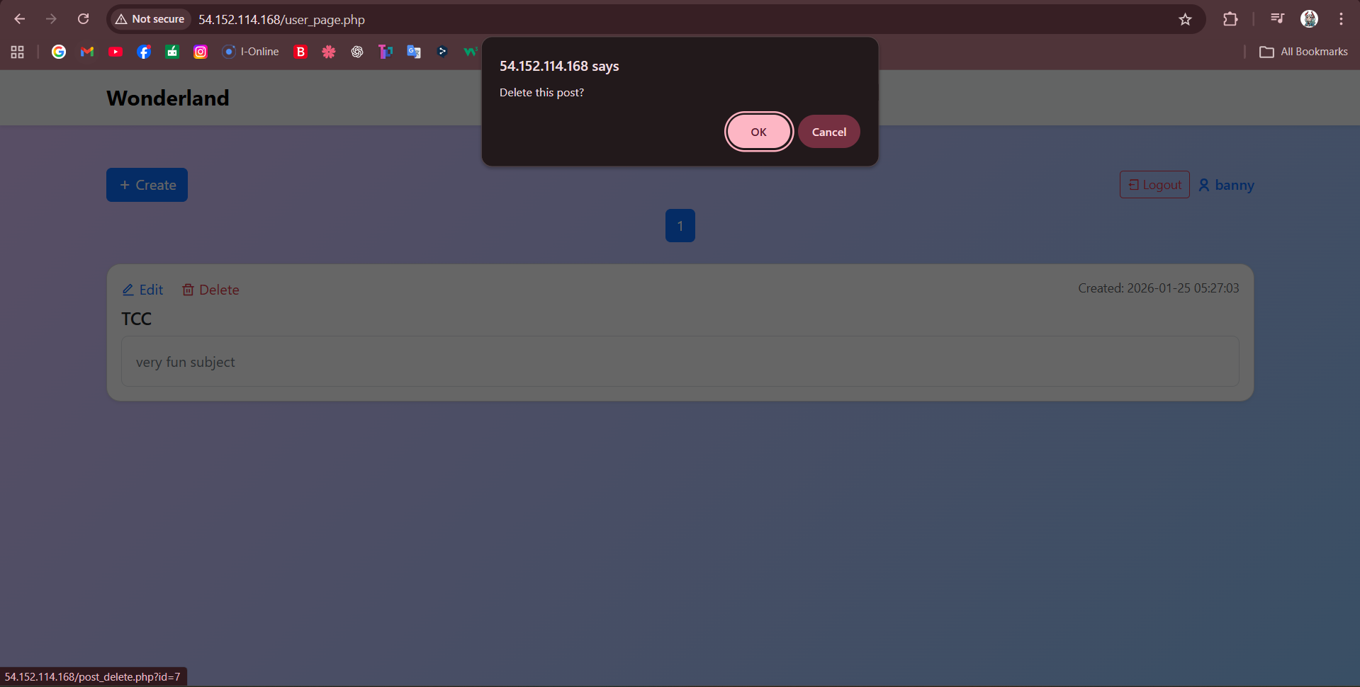

Figure 7 Delete confirmation page

# Phase 1

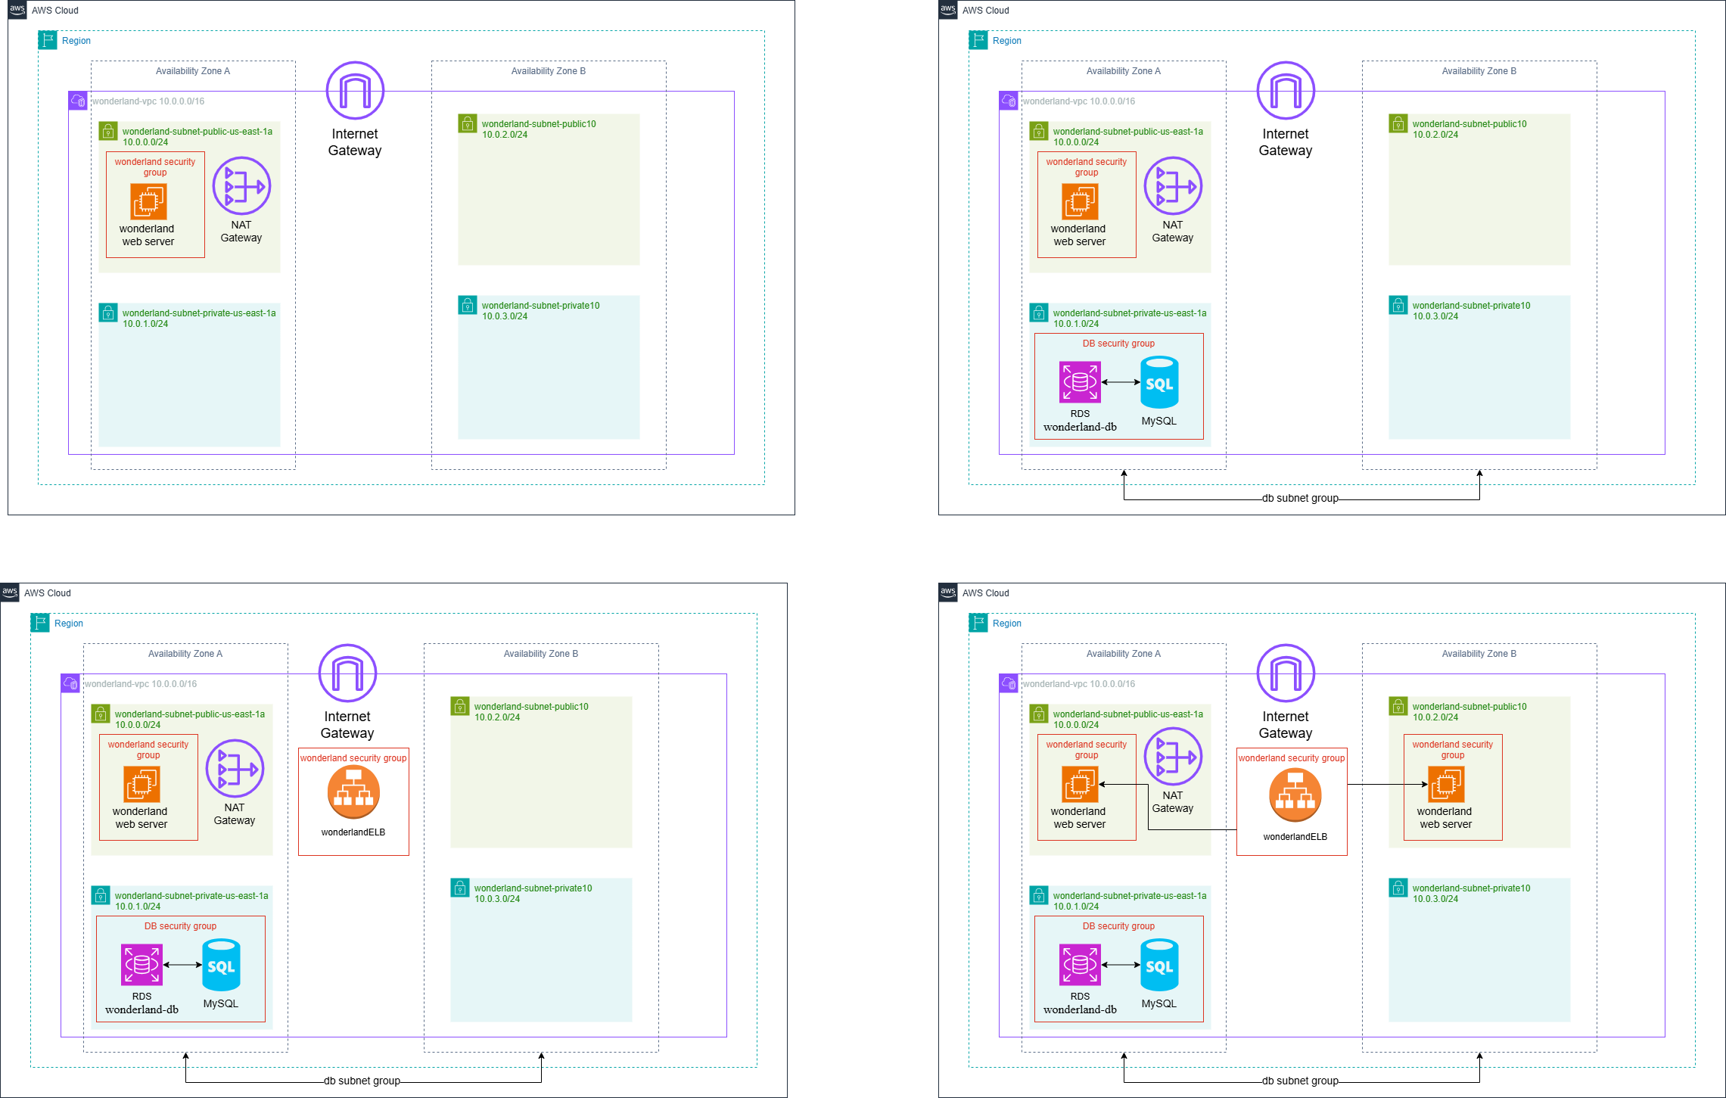

Figure 8 Phase 1 Layout Diagram of the Network

The Phase 1 foundation network architecture of the Wonderland Web Application in the AWS cloud is shown in figure 8. The architecture is deployed on a Virtual Private Cloud (VPC) called wonderland-vpc whose IPv4 CIDR block is 10.0.0.0/16. This VPC offers a highly secure and logically isolated virtual networking environment which serves as the dedicated cloud platform to execute the application.

The infrastructure is spread over two availability zones (AZs) to increase availability and reliability. This multi-AZ architecture adheres to the best practices of cloud computing by enhancing fault tolerance and enabling uninterrupted service delivery in case of failure in one of the zones.

The network is further divided into two public subnets and two private subnets creating a structured and safe network topology. Public subnets are meant to be used to serve resources which are facing the internet whereas the private subnets are meant to be used by in-house services. Internet connectivity is provided by an Internet Gateway (IGW) which is connected to the VPC. Also, a NAT Gateway enables the resources in the private subnets to establish outgoing internet communications without blocking unsolicited inbound traffic.

At this stage, an Amazon EC2 instance as a web server is launched on the public subnet and can be accessed directly by the Internet. Even though such configuration is simple and fast to implement, it leaves the server to the open world and is not scalable and has no sophisticated security features.

**Step 1: Create VPC**

First, we will create a VPC. This is crucial because the VPC is the foundation of the AWS cloud network architecture. All cloud resources, such as EC2 instances, subnets, load balancers, etc., must be deployed within a VPC. By creating a VPC, we can define the IP address range of the entire network and effectively plan public and private subnets, thereby improving system security and manageability. Therefore, before deploying any subsequent resources, a VPC must be established as the foundation of the overall network architecture.

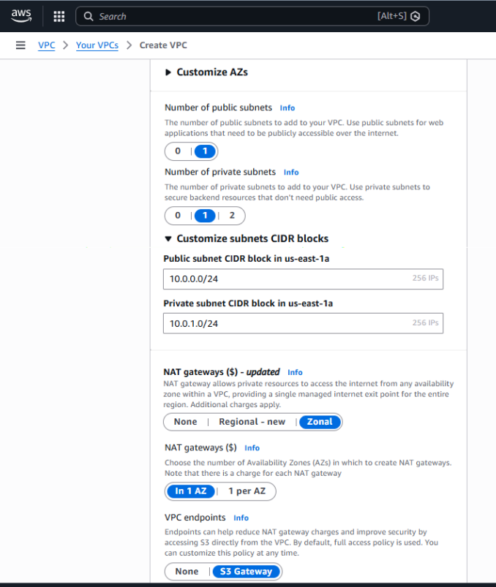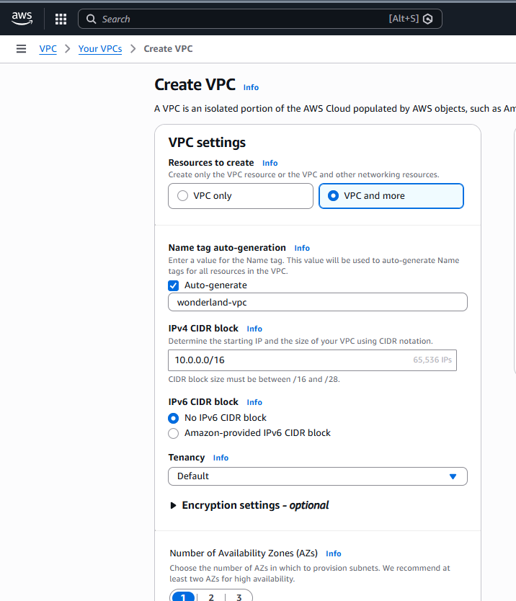

Figure 9 VPC configuration page

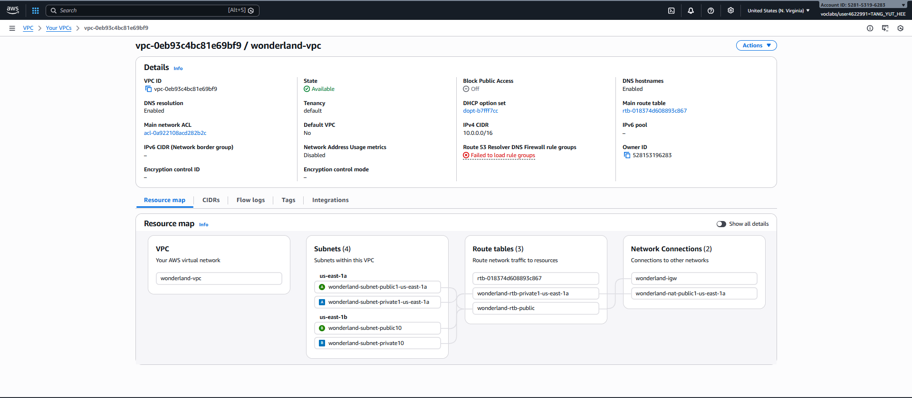

Figure 10 Details of wonderland-vpc

**Step 2: Create Additional Subnets**

In this task, an additional subnet is created within a second Availability Zone within the same VPC. The primary purpose is to improve system high availability. Since each subnet can only exist in a single Availability Zone, creating multiple subnets in different Availability Zones prevents the entire system from becoming inoperable due to the failure of a single Availability Zone.

By deploying subnets across multiple Availability Zones, the system can support cloud features such as load balancing and auto scaling, allowing EC2 instances to run distributed across different Availability Zones. This improves system stability, fault tolerance, and overall availability.

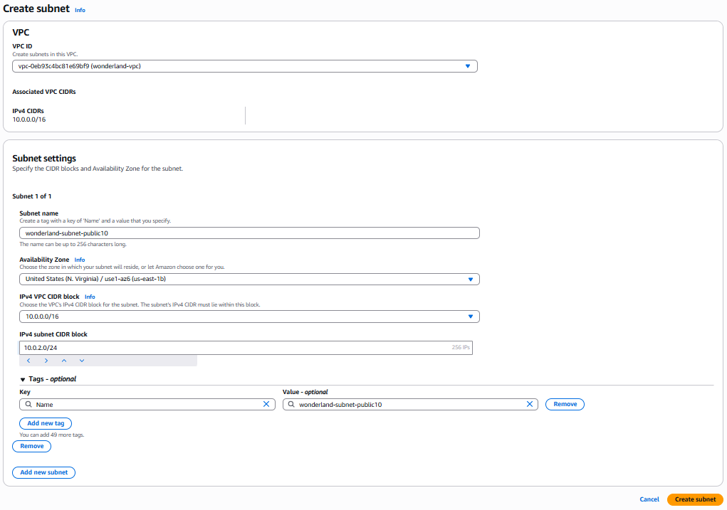

Figure 11 Details of create wonderland-subnet-public10

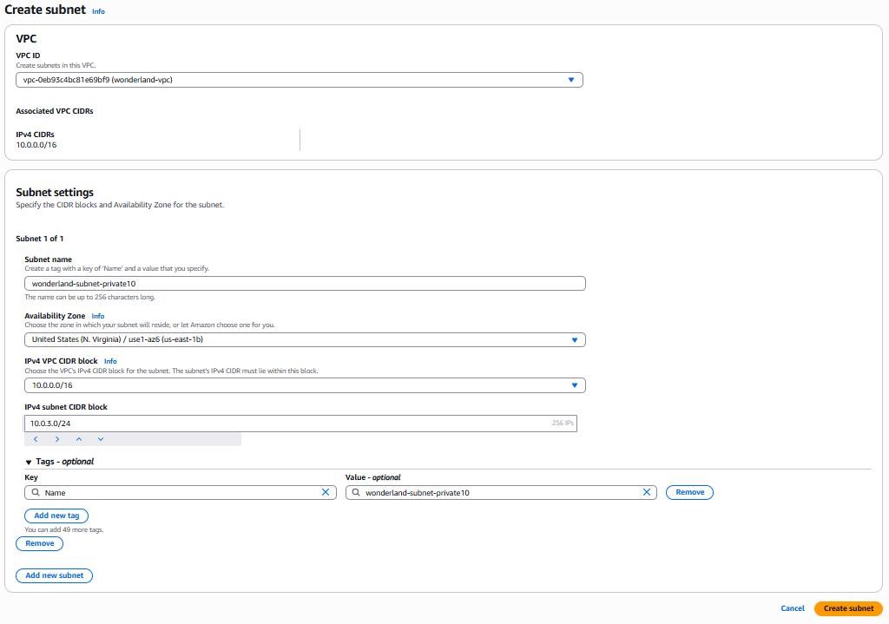

Figure 12 Details of create wonderland-subnet-private10

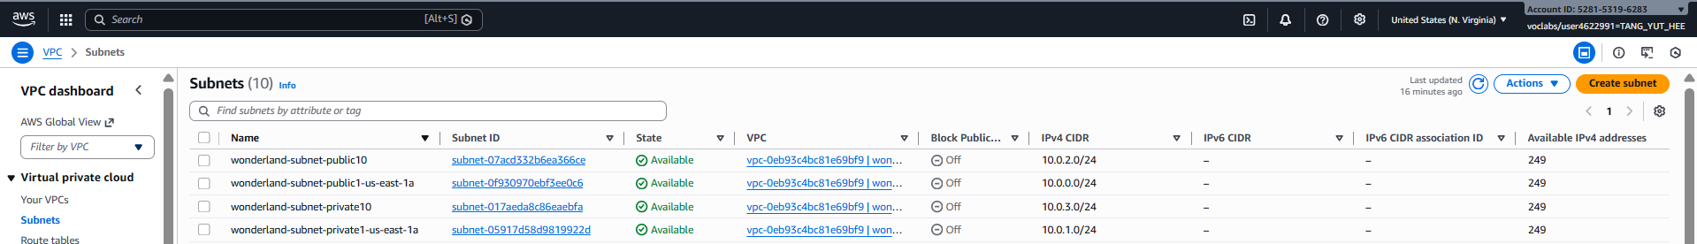

Figure 13 Subnets Dashboard

**Step 3: Edit Subnets Associations**

After creating the additional subnet, the next step is to configure the subnet association in the route table. We will associate the private subnet with the `wonderland-rtb-private1-us-east-1a` route table, and the public subnet with the `wonderland-rtb-public` route table, depending on the subnet's purpose.

The main purpose of this configuration is to ensure that different subnets follow their respective correct network routing rules. The route table used by the public subnet contains a default route (0.0.0.0/0) to the Internet Gateway, enabling resources deployed in the public subnet to communicate with the external Internet. This is suitable for components that provide services externally, such as web servers or load balancers. Conversely, the route table associated with the private subnet does not have a direct route to the Internet Gateway, thus limiting its external connectivity to protect backend resources (such as databases) from direct access from the public network.

Furthermore, by classifying subnets within different Availability Zones into the same type of routing table, multi-AZ routing consistency can be ensured. This not only improves the security and manageability of the overall network architecture but also lays a solid network foundation for the subsequent deployment of load balancers and auto-scaling functionality.

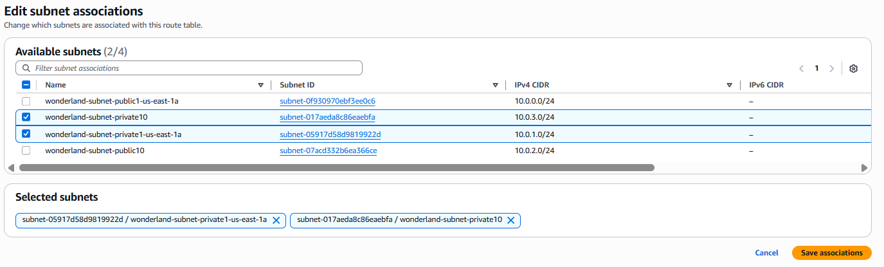

Figure 14 Edit Private Subnets Associations

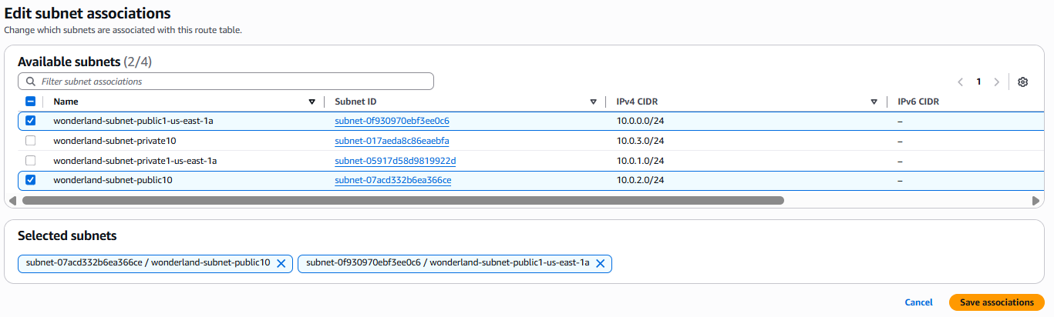

Figure 15 Edit Public Subnets Associations

**Step 4: Create VPC Security Group**

Here we created a VPC security group to act as a virtual firewall, controlling inbound and outbound traffic to the instance. We configured three inbound rules, allowing SSH (port 22), HTTP (port 80), and HTTPS (port 443) access from any origin (0.0.0.0/0). The SSH rules support secure remote management of the server, while the HTTP and HTTPS rules allow users to access web applications via standard web protocols. For outbound traffic, all traffic is allowed to ensure the server can communicate with external services (such as updates or database connections). This configuration guarantees both user and administrator access rights while maintaining controlled and secure network access.

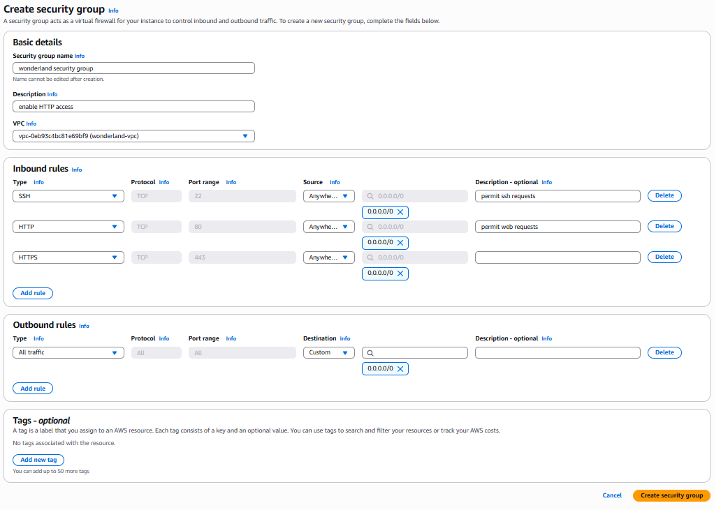

Figure 16 Configuration of Security Group

**Step 5: Upload source code to GitHub repository**

The project source code was stored in a GitHub repository to enable automated deployment. During the EC2 instance launch, user data scripts were used to automatically download and configure the application, ensuring a faster and more consistent setup process.

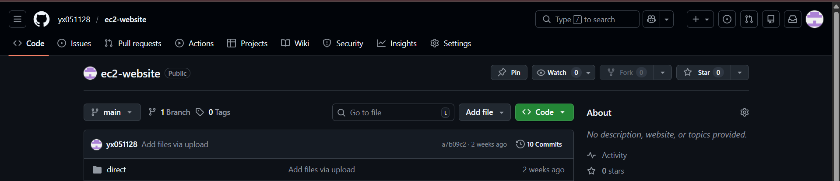

Figure 17 GitHub repository

**Step 6: Launch a Web Server Instance**

In this task, an Amazon EC2 instance named “wonderland web server” was launched within the newly created VPC. The instance type t2.micro was selected due to its lightweight resource requirements and cost-effectiveness, making it suitable for hosting a small-scale web application. The purpose of this instance is to function as a web server that delivers the application to users over HTTP and HTTPS, while also allowing remote administration through SSH. This setup enables the deployment, testing, and hosting of the Wonderland web system in a cloud environment.

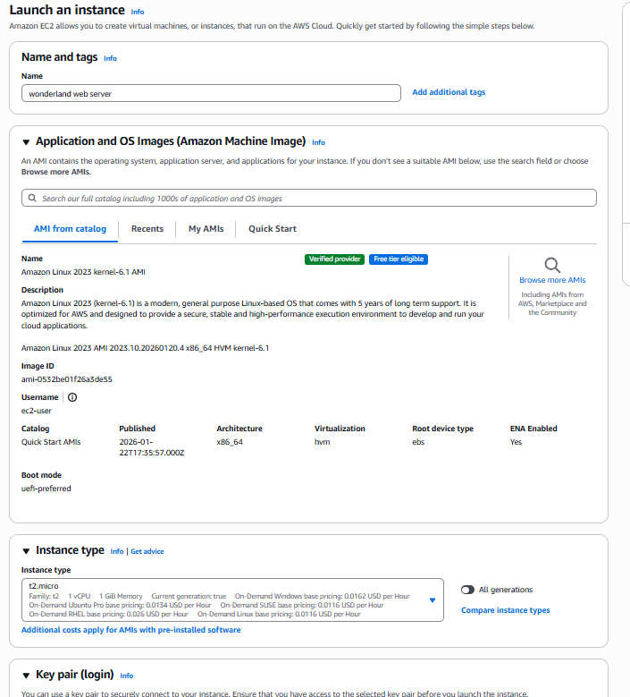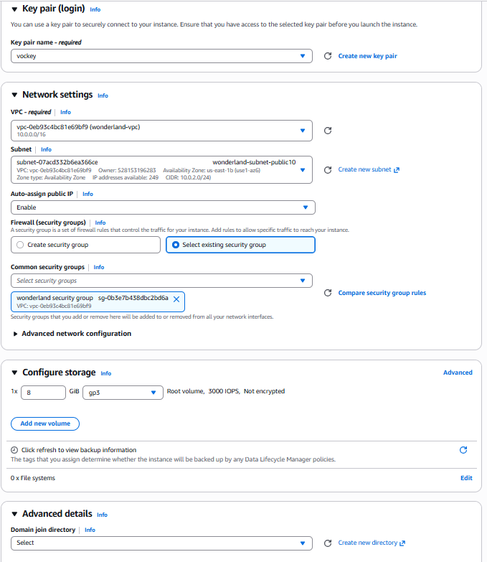

Figure 18 Configuration of instances

Clicking on "Advanced details" will allow us to see the "user data" text field.This user data script plays a critical role in automating the server setup process. When the EC2 instance is launched, the script automatically updates the system, installs required packages such as Apache, PHP, MariaDB, and Git, and starts the necessary services. It then retrieves the application source code from the GitHub repository, configures the web directory, and initializes the MySQL database with the required schema. This automation eliminates manual configuration, ensures consistent deployment, and significantly reduces setup time, enabling the instance to function as a fully operational web server immediately after launch.

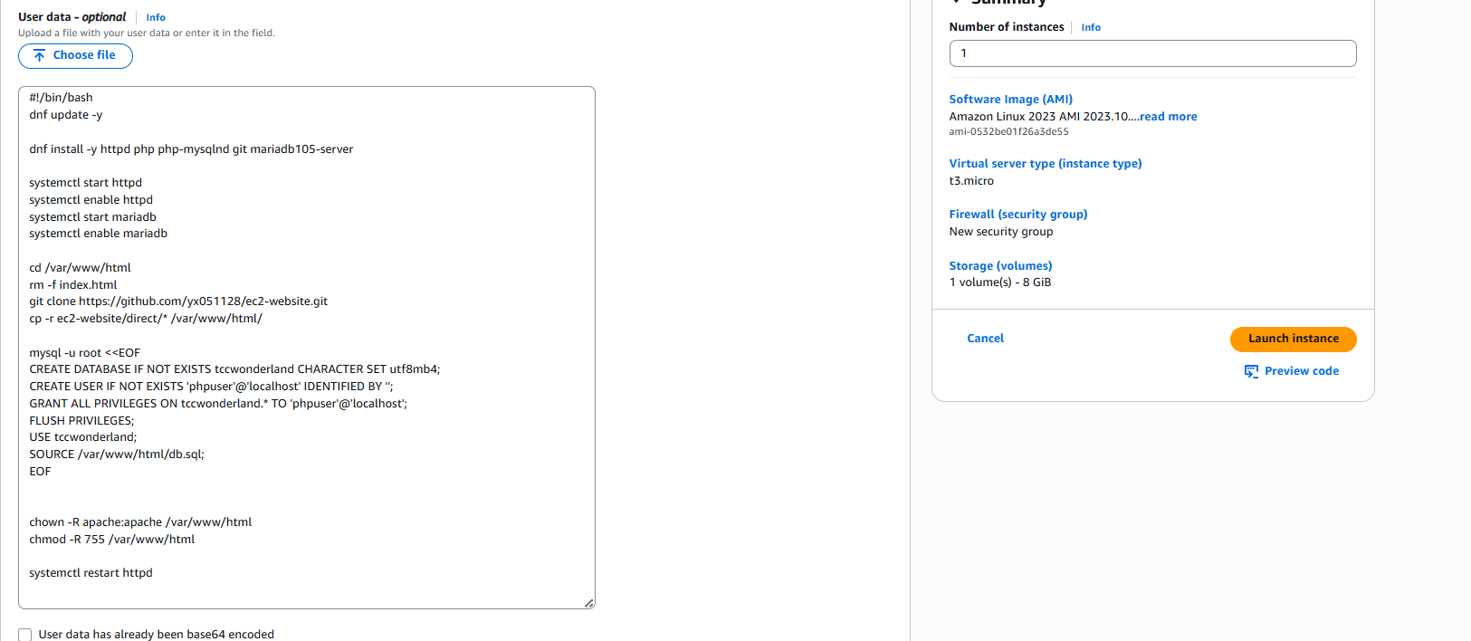

Figure 19 Configuration of user data

Figure 19 clearly shows the details of the Wonderland web server. We can see the Public IPv4 address. With copying this IP address will allow us to access our web server.

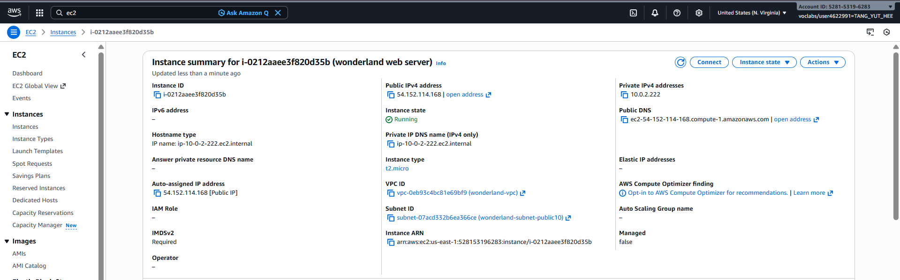

Figure 20 Details of wonderland web server

Finally, we can access our webpage via http://54.152.114.168/.

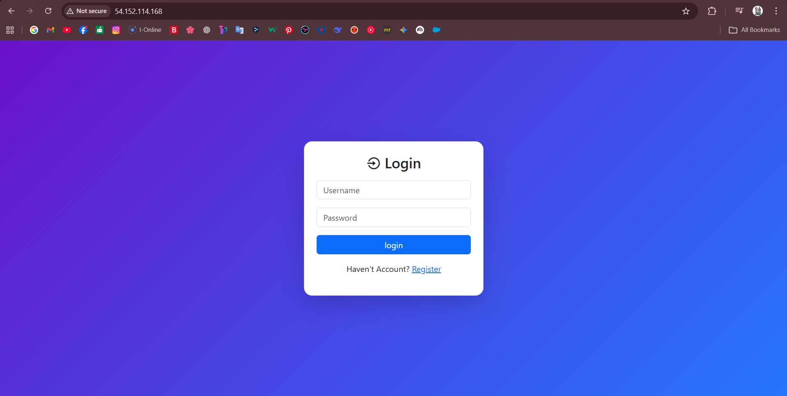

Figure 21 successful login to web

# Phase 2



Figure 22 Phase 2 Layout Diagram of the Network

The Phase 2 architecture, shown in Figure 22, is a two-tier design, as the system is developed into a two-tier system with the separation of the web and database layers. Besides the already existing EC2 web server in the public subnet, the introduction of an Amazon RDS MySQL database instance in the private subnet is also provided.

This isolation helps in improving the level of security by keeping sensitive database resources out of the direct Internet exposure. Only through a specific database security group, the database can be accessed and only by the web server using port 3306. Consequently, outside users do not have direct access or attacking the database layer.

Such an architectural upgrade increases system reliability, data protection, and maintainability. The design adheres to AWS security best practices by isolating the application and data layer, as well as minimizing possible attack surfaces. However, the traffic continues to access the EC2 instance directly and the system still relies on one web server, which is not scalable or available.

**Step 1:Create Database Security Group**

A new security group named “DB security group” was created specifically for the database layer. The inbound rule allows MySQL/Aurora traffic (port 3306), with the source restricted to the “wonderland security group” instead of allowing public access. This configuration ensures that only the web server instances associated with the Wonderland security group are permitted to communicate with the database. By restricting access at the security group level, the database is protected from direct internet exposure, reducing potential security risks and following the principle of least privilege. This design enhances overall system security and aligns with AWS best practices for multi-tier architectures.

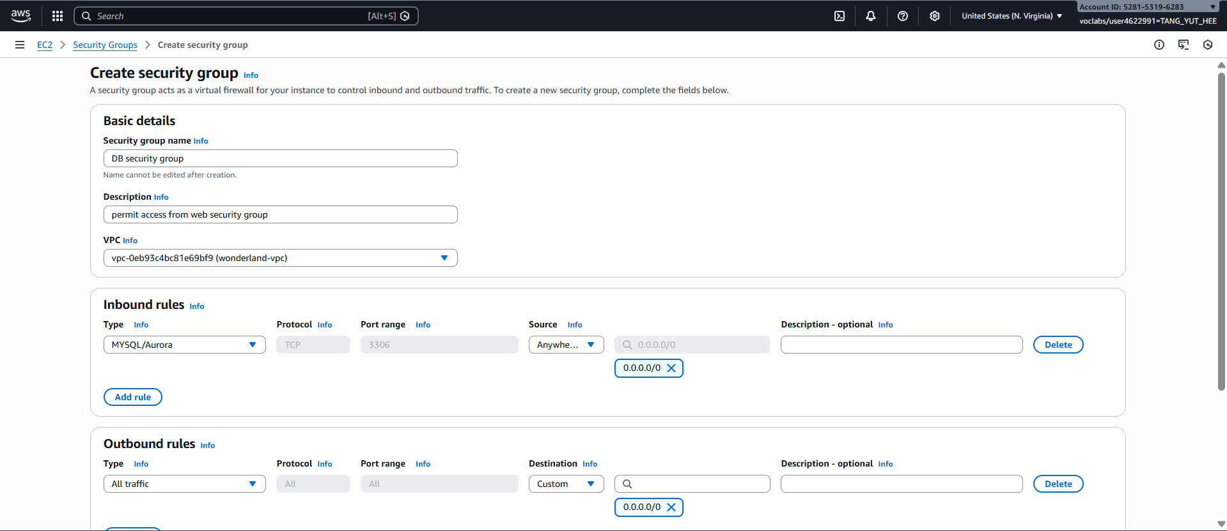

Figure 23 Configuration of DB security group

**Step 2: Create Database Subnet Group**

A new database subnet group named “DB subnet group” was created to host the database resources. It includes private subnets from both Availability Zones (us-east-1a and us-east-1b). By placing the database in private subnets, direct internet access is prevented, which enhances security and protects sensitive data. Distributing the subnets across multiple Availability Zones also improves high availability and fault tolerance, ensuring that the database remains accessible even if one Availability Zone experiences failure.

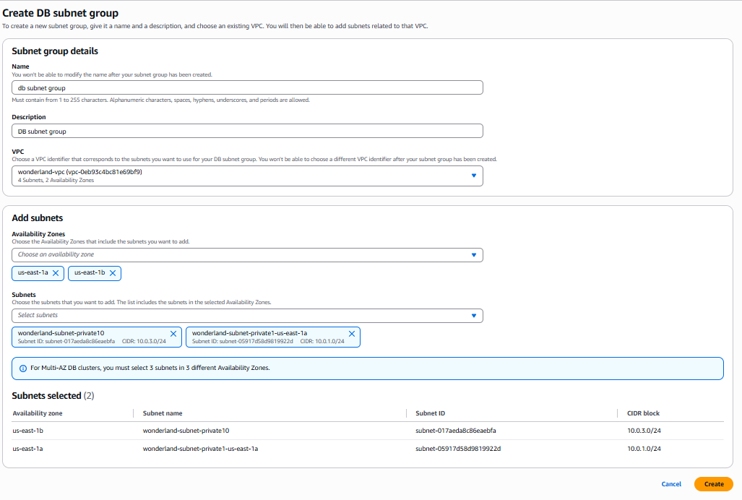

Figure 24 Configuration of DB subnet group

**Step 3: Create an Amazon RDS DB Instance**

From Figure 23, the details of the wonderland-db instance can be observed. The database engine is identified as MySQL, and the endpoint information is provided, which allows the web server to establish a connection to the database. The endpoint is particularly important as it serves as the address used by the application to communicate with the database service.

Figure 24 shows the configuration settings of the database instance. The database name is configured as wonderlandDB, running on a t3.micro instance type with 20 GB of allocated storage. The master username is set to admin, along with the corresponding credentials for authentication. These configurations ensure that the database has sufficient resources while remaining cost-effective for small-scale deployment and testing.

The purpose of this setup is to replace the local MariaDB database hosted on the EC2 instance with a managed Amazon RDS MySQL database. By using RDS, database management tasks such as maintenance, backups, and scaling are handled automatically, improving reliability, security, and overall system performance.

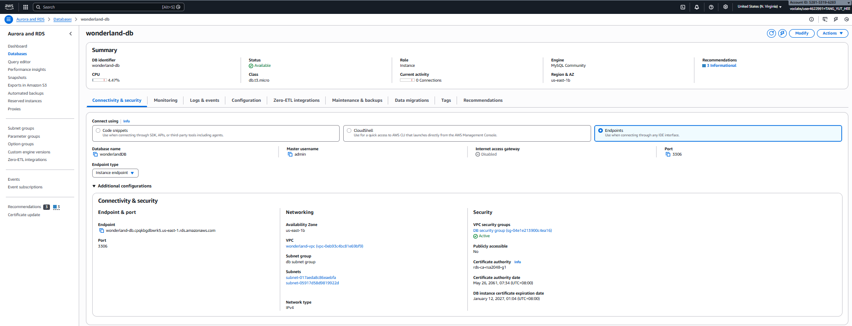

Figure 25 Information of wonderland-db

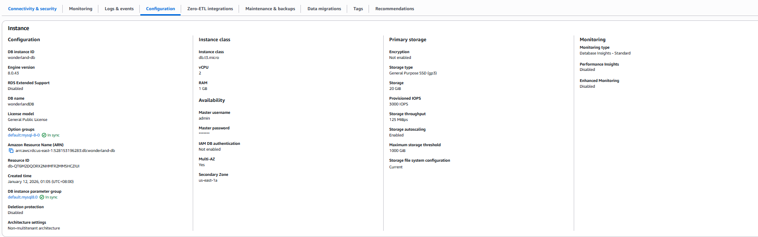

Figure 26 Configuration of wonderland-db

**Step 4: Dump local MYSQL**

We first connected to the EC2 instance via SSH to access the local database environment. As shown in Figure 25, the database was successfully exported using the mysqldump command, generating a SQL dump file (tccwonderland_dump.sql). This file serves as a backup and will be used for migration to the Amazon RDS database.

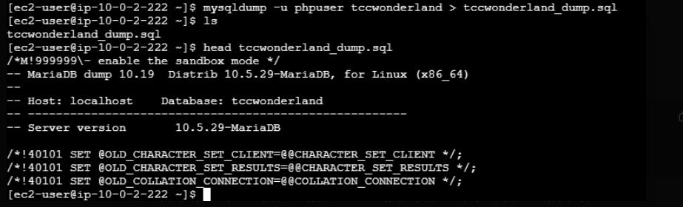

Figure 27 MySQL Database Dump Generated Using mysqldump

In Figure 25, a connection was established to the Amazon RDS endpoint, where a new database named tccwonderland was created. This database serves as the target environment for the migration process.

In Figure 26, the previously exported SQL dump file (tccwonderland_dump.sql) was imported into the RDS database. This step restores all tables, structures, and data from the local MariaDB instance to the managed RDS service, completing the database migration.



Figure 28 Create database in rds



Figure 29 Dump SQL

**Step 5: Modify Database Connection Settings in config.php**

In this step, the database configuration file (config.php) was updated to connect to the Amazon RDS instance. The dbhost parameter was changed to the RDS endpoint, while the dbuser and dbpass were updated to the RDS credentials configured during setup (admin and the corresponding password). This allows the application to establish a remote connection to the managed database instead of the local MariaDB instance.

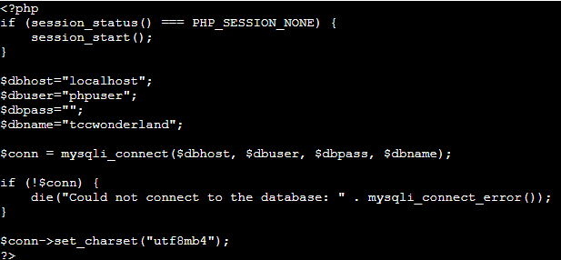

Figure 30 config.php(before)

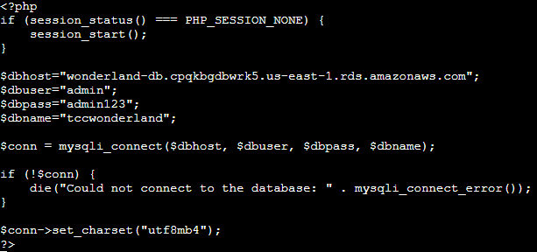

Figure 31 config.php(after)

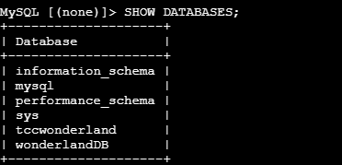

Figure 32 Databases list

# Phase 3

The objective of this phase is to introduce an **Application Load Balancer (ALB)** to efficiently manage and route external user traffic to the web server instances. This enhances the system architecture by adding an additional layer between users and the application servers, improving traffic distribution and fault tolerance. Implementing the ALB also prepares the system for **high availability, reliability, and future scalability**, ensuring that the infrastructure can handle increasing user demand and potential server failures without disrupting service.



Figure 33 Phase 3 Layout Diagram of the Network

The final Phase 3 architecture is shown in figure 33 and it adds an Application Load Balancer (ALB) to create a secure and scalable three-tier architecture. The ALB acts as the customer-facing endpoint of all client requests and routes traffic received to registered EC2 instances using a target group.

Under this improvement, the users do not access the web server directly. Rather, it directs the traffic through the load balancer that only forwards the request to healthy targets as a result of ongoing health checks. The security group of the web server is also set up in such a way that only the load balancer can access it over HTTP, which essentially prevents direct access by the population and enhances the general security.

The database layer is also deployed in the private subnets and still accepts connection only by the web server. The layered architecture guarantees that the application and database components are not exposed to external environment.

Phase 3 dramatically enhances scalability, availability, and fault tolerance by adding load balancing, monitoring health, and isolation of a network. The system will be compatible with the production-level deployment and increase failure recovery, as it can support traffic distribution, future horizontal scale, and automatic recovery of failures and is in line with the best practices of AWS cloud architecture.

Step 1: Create Target Group

|  |  |
| --- | --- |
| **Target group name** | targetwonderland |
| **VPC** | wonderland-vpc |
| **Target type** | Instance |
| Protocol / Port | HTTP / 80 |
| **Health check protocol / path** | HTTP → / (default) |
| **Registration** | registered the EC2 instance(s) that host the PHP application as targets. |
| **Expected behaviour** | ALB will periodically call the health check path and mark targets healthy/unhealthy based on responses. |

Table 1 Target Group

**Target Group Overview**

This screenshot presents the details of the **target group targetwonderland**, which is responsible for directing traffic from the load balancer to the EC2 web server instances. The target group operates within the same VPC (wonderland-vpc) and uses the **HTTP protocol on port 80**. The health check configuration ensures that only properly functioning servers receive user traffic.

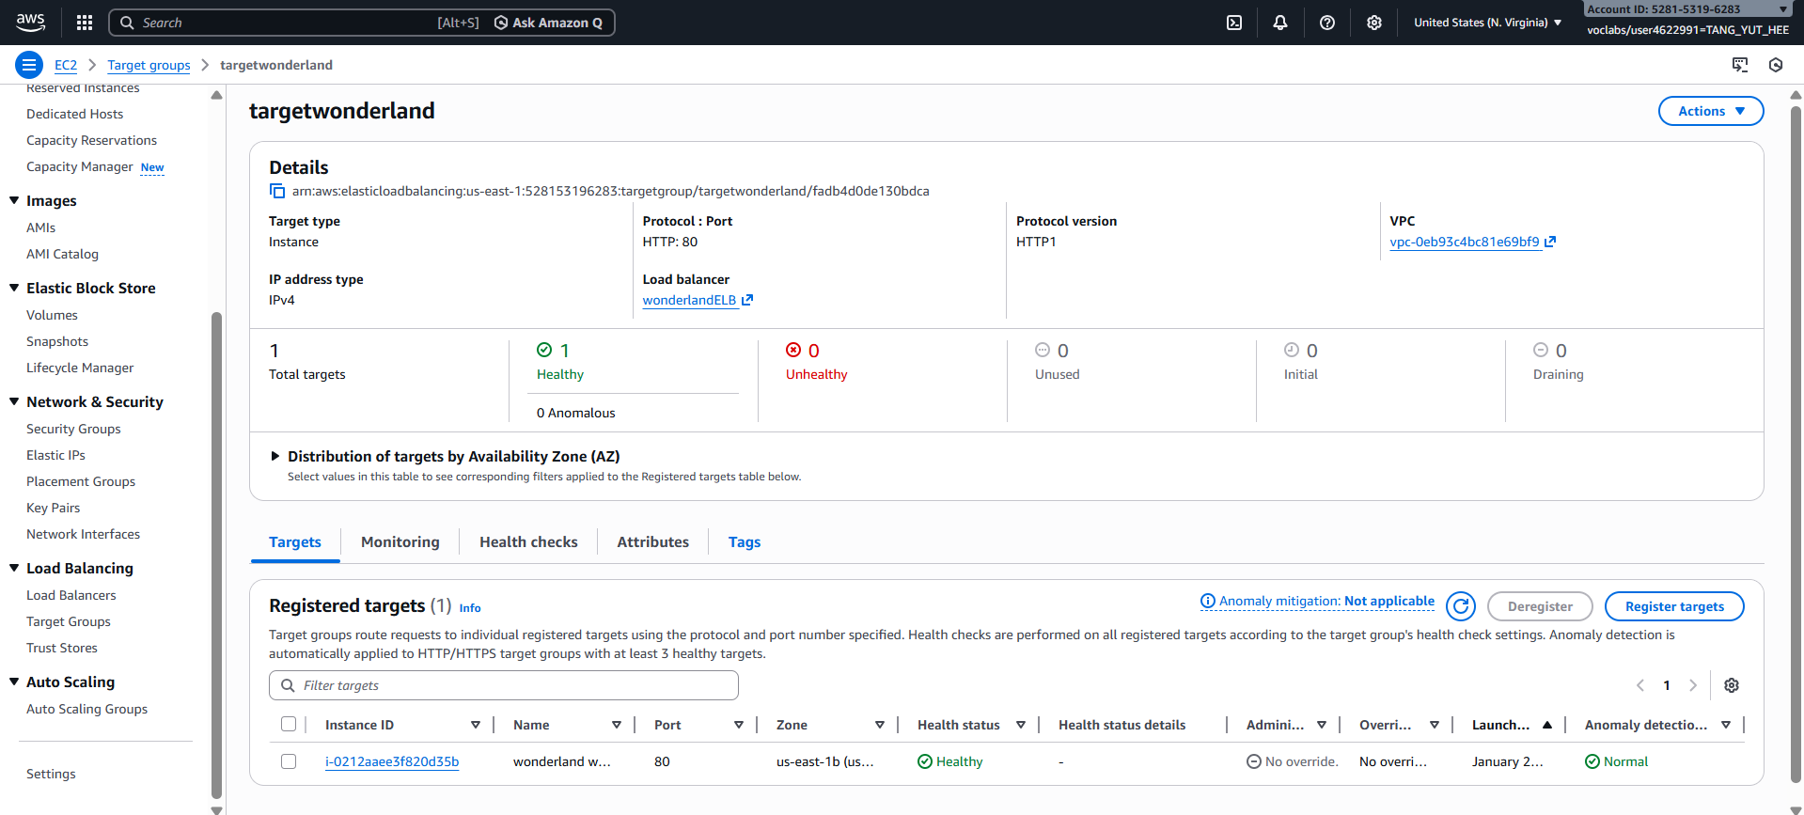

Figure 34 Target group targetwonderland configuration (HTTP:80, VPC: wonderland-vpc)

**Target Group Health Status**

This screenshot shows the **registered targets** (EC2 instances) within the target group and their **health status**. The status **“Healthy”** confirms that the web server is running correctly and responding to the load balancer’s health checks. This ensures that user requests will only be routed to operational servers, improving reliability and user experience.

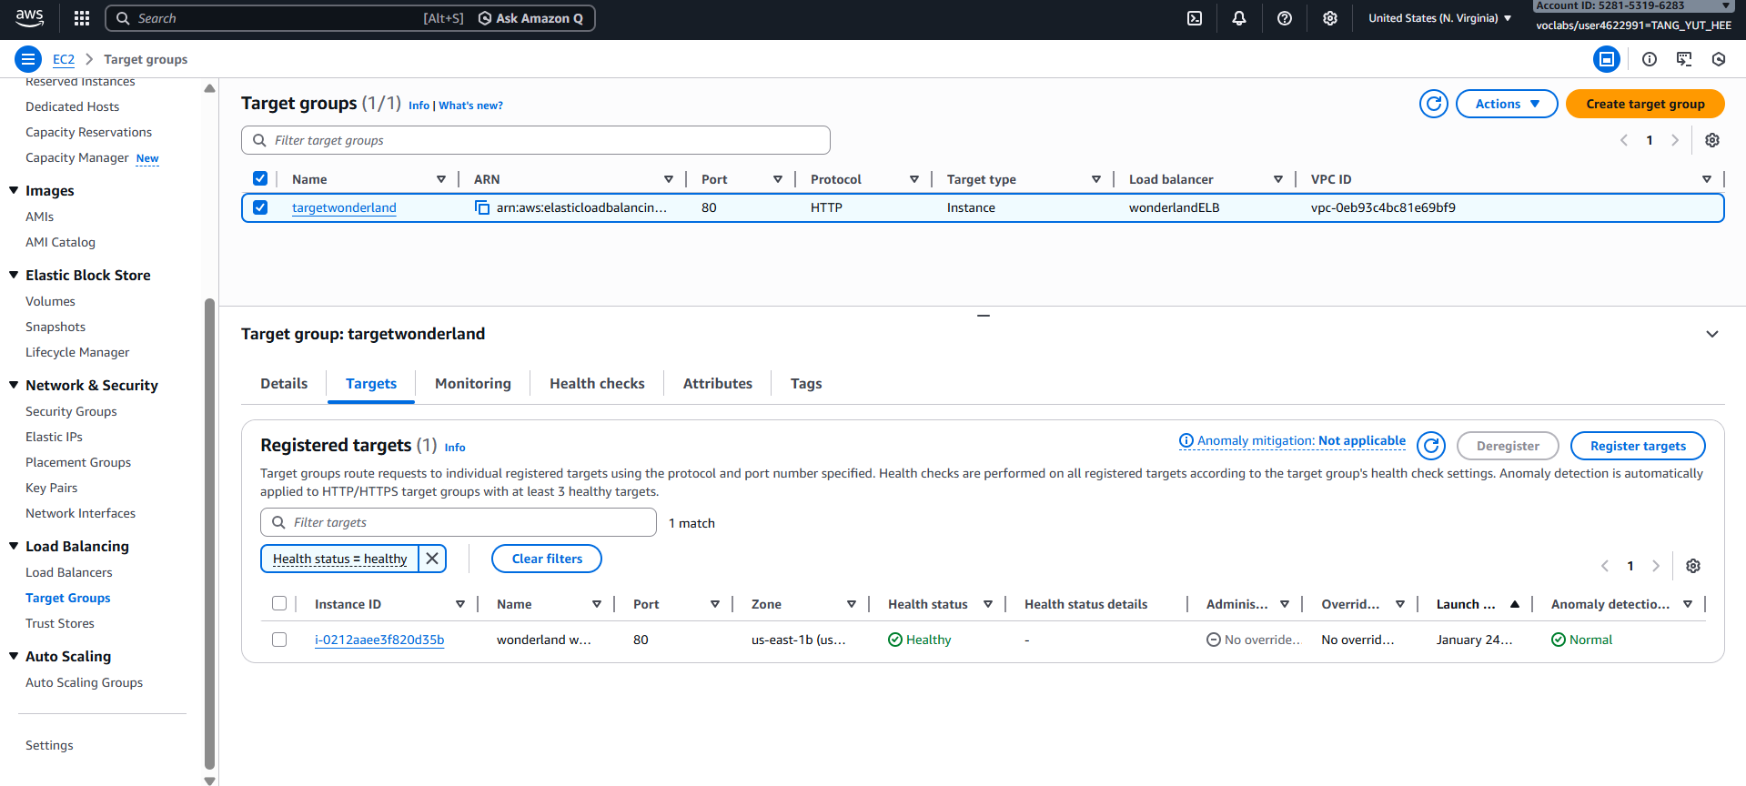

Figure 35 Registered EC2 targets and health status for targetwonderland (Healthy)

**Application Load Balancer Overview**

This screenshot shows the summary page of the **Application Load Balancer (ALB)** named **wonderlandELB**. The load balancer is configured as **Internet-facing**, meaning it accepts traffic from users over the internet. It is deployed inside the **wonderland-vpc** and spans multiple Availability Zones to ensure high availability. The **DNS name** displayed here is used by users to access the web application. The load balancer state is **Active**, confirming that it is successfully provisioned and ready to route traffic.

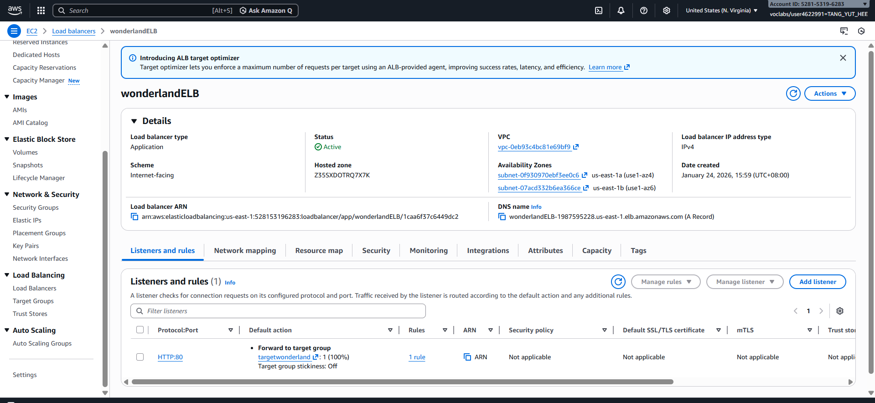

Figure 36 Application Load Balancer wonderlandELB (Active) and DNS name

Step 2: Create Application Load Balancer (ALB)

|  |  |
| --- | --- |
| **Load balancer name** | wonderlandELB |
| **Scheme** | Internet-Facing |
| **VPC** | wonderland-vpc (same VPC as the target group)  VPC ID [vpc-0eb93c4bc81e69bf9](https://us-east-1.console.aws.amazon.com/vpc/home?region=us-east-1#VpcDetails:VpcId=vpc-0eb93c4bc81e69bf9) |
| **Availability Zones / Subnets** | * wonderland-subnet-public1-us-east-1a * wonderland-subnet-public-public10   (both public subnets in different AZs for high availability) |
| **IP address type** | IPv4 |
| **Security group** | wonderland security group (allows inbound HTTP port 80 from the Internet) |
| **Listener configuration** | HTTP : 80 → forward to target group targetwonderland |
| **Post-creation checks** | confirm ALB state = **Active**, copy ALB DNS name for verification. |

Table 2 Application Load Balancer (ALB)

**ALB Security Group Association**

This screenshot shows the **security group attached to the Application Load Balancer**. The security group acts as a virtual firewall that controls inbound and outbound traffic. Associating a dedicated security group with the ALB ensures that only approved traffic can reach the load balancer.

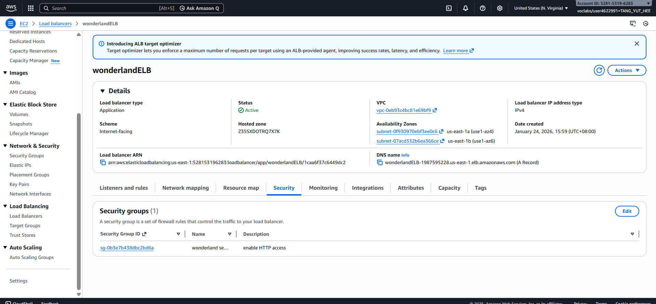

Figure 37 Application Load Balancer wonderlandELB showing associated security group

**ALB Security Group Inbound Rules**

This screenshot displays the **inbound rules** of the ALB security group. The rule allows **HTTP traffic (Port 80) from anywhere (0.0.0.0/0)**, enabling users on the internet to access the web application through the load balancer. This configuration is necessary for public accessibility while still maintaining controlled access at the instance level.

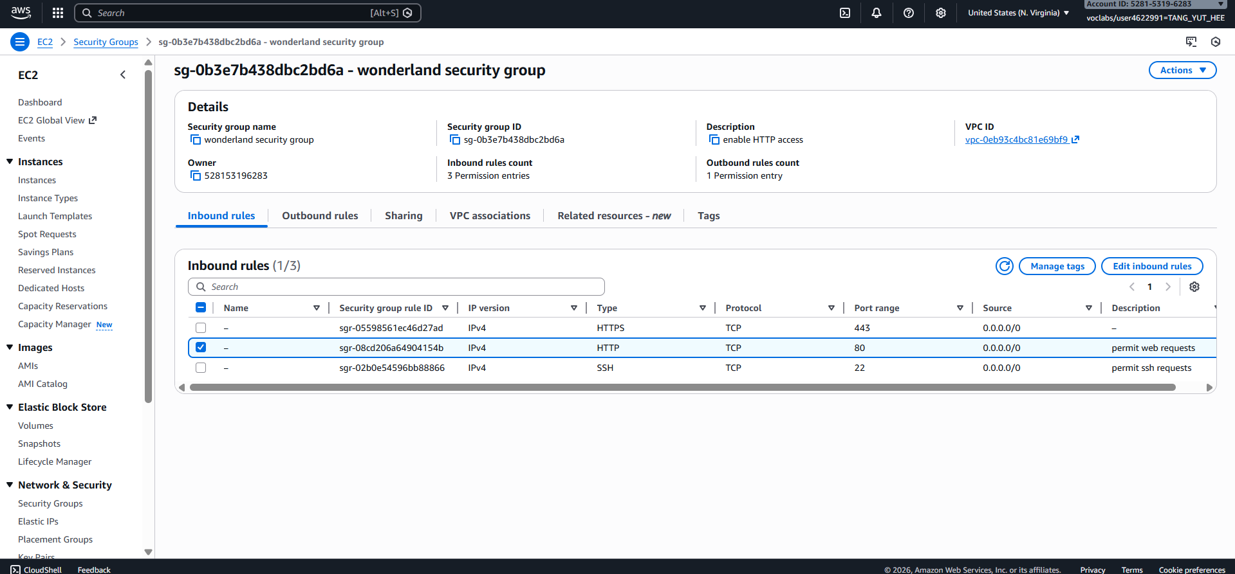

Figure 38 Inbound rules of ALB security group allowing HTTP traffic from the internet

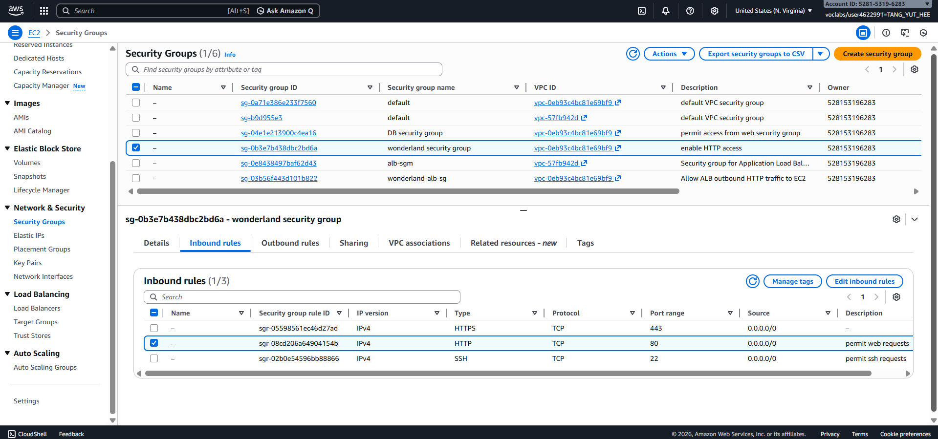

Figure 39 EC2 security group allowing HTTP from ALB security group (restricts direct public access)

ALB (wonderlandELB): key details

|  |  |
| --- | --- |
| **Name** | wonderlandELB |
| **Type** | Application Load Balancer (ALB) |
| **Schema** | Internet-Facing |
| **VPC** | wonderland-vpc |
| **Subnets / AZs** | wonderland-subnet-public1-us-east-1a, wonderland-subnet-public-public10 |
| **Security group** | wonderland security group |
| **Listener** | 80 → Default action: Forward to targetwonderland |
| **DNS name** | wonderlandELB-1987595228.us-east-1.elb.amazonaws.com |

Table 3 ALB (wonderlandELB)

**Website Access via Load Balancer DNS**

This screenshot shows the web application successfully accessed using the **ALB DNS name** in a browser. This confirms that traffic flows correctly through the system: **User → Load Balancer → EC2 Web Server → RDS Database**. The successful page load verifies that the load balancer is functioning as intended.

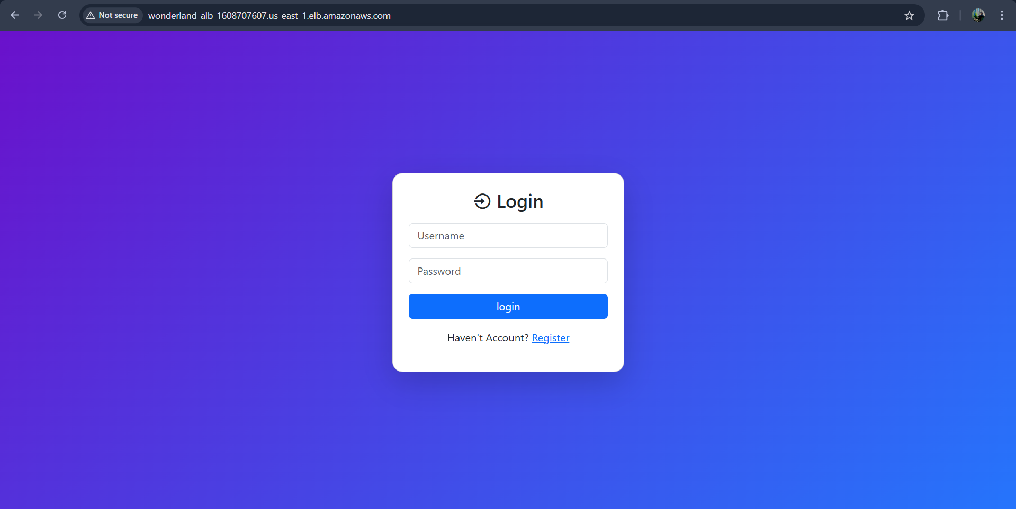

Figure 40 Application accessed via ALB DNS confirming end-to-end connectivity

RDS Database Status

This screenshot shows the **Amazon RDS database instance** used by the application. The database status is **Available**, indicating that it is operational and ready to serve database requests from the EC2 web server. This completes the 3-tier architecture by providing a managed backend database.

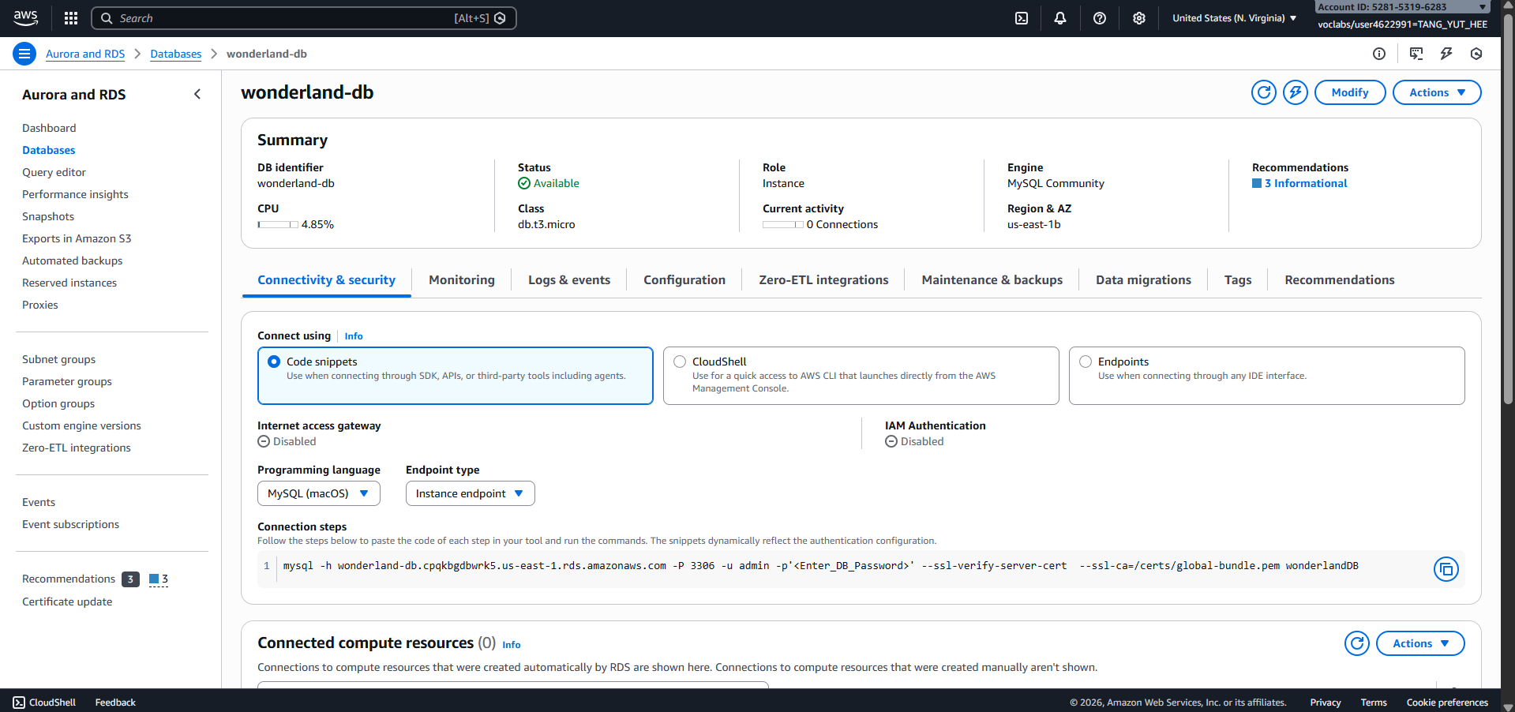

Figure 41 RDS instance wonderland-db status and endpoint (used by EC2 application)

What to test (and what the results mean)

1. **Target health:** Health status for each registered instance must be **Healthy**.
2. Healthy → ALB can route traffic successfully to the EC2.
3. **Browser test (end-to-end):** open <http://wonderlandelb-1987595228.us-east-1.elb.amazonaws.com/> > and confirm the website loads (login page, home page).
4. Loads via ALB DNS → confirms **User → ALB → EC2** path works.
5. **DB connectivity check:** confirm the application can access the RDS database (test a DB-backed page or run a test query from the app).
6. Successful DB queries → confirms **EC2 → RDS** path works

**Phase 3 successfully implemented a 3-tier cloud architecture by introducing an Application Load Balancer between users and the EC2 web server.** The load balancer distributes incoming traffic and performs health checks to ensure requests are only sent to healthy instances. Security was enhanced by restricting direct public access to the EC2 instance and allowing traffic only through the load balancer. The system now operates as:

**User → Application Load Balancer → EC2 (PHP) → RDS (MySQL)**

This architecture improves **availability, reliability, and scalability**, and prepares the system for **Auto Scaling in Phase 4**.

# Phase 4

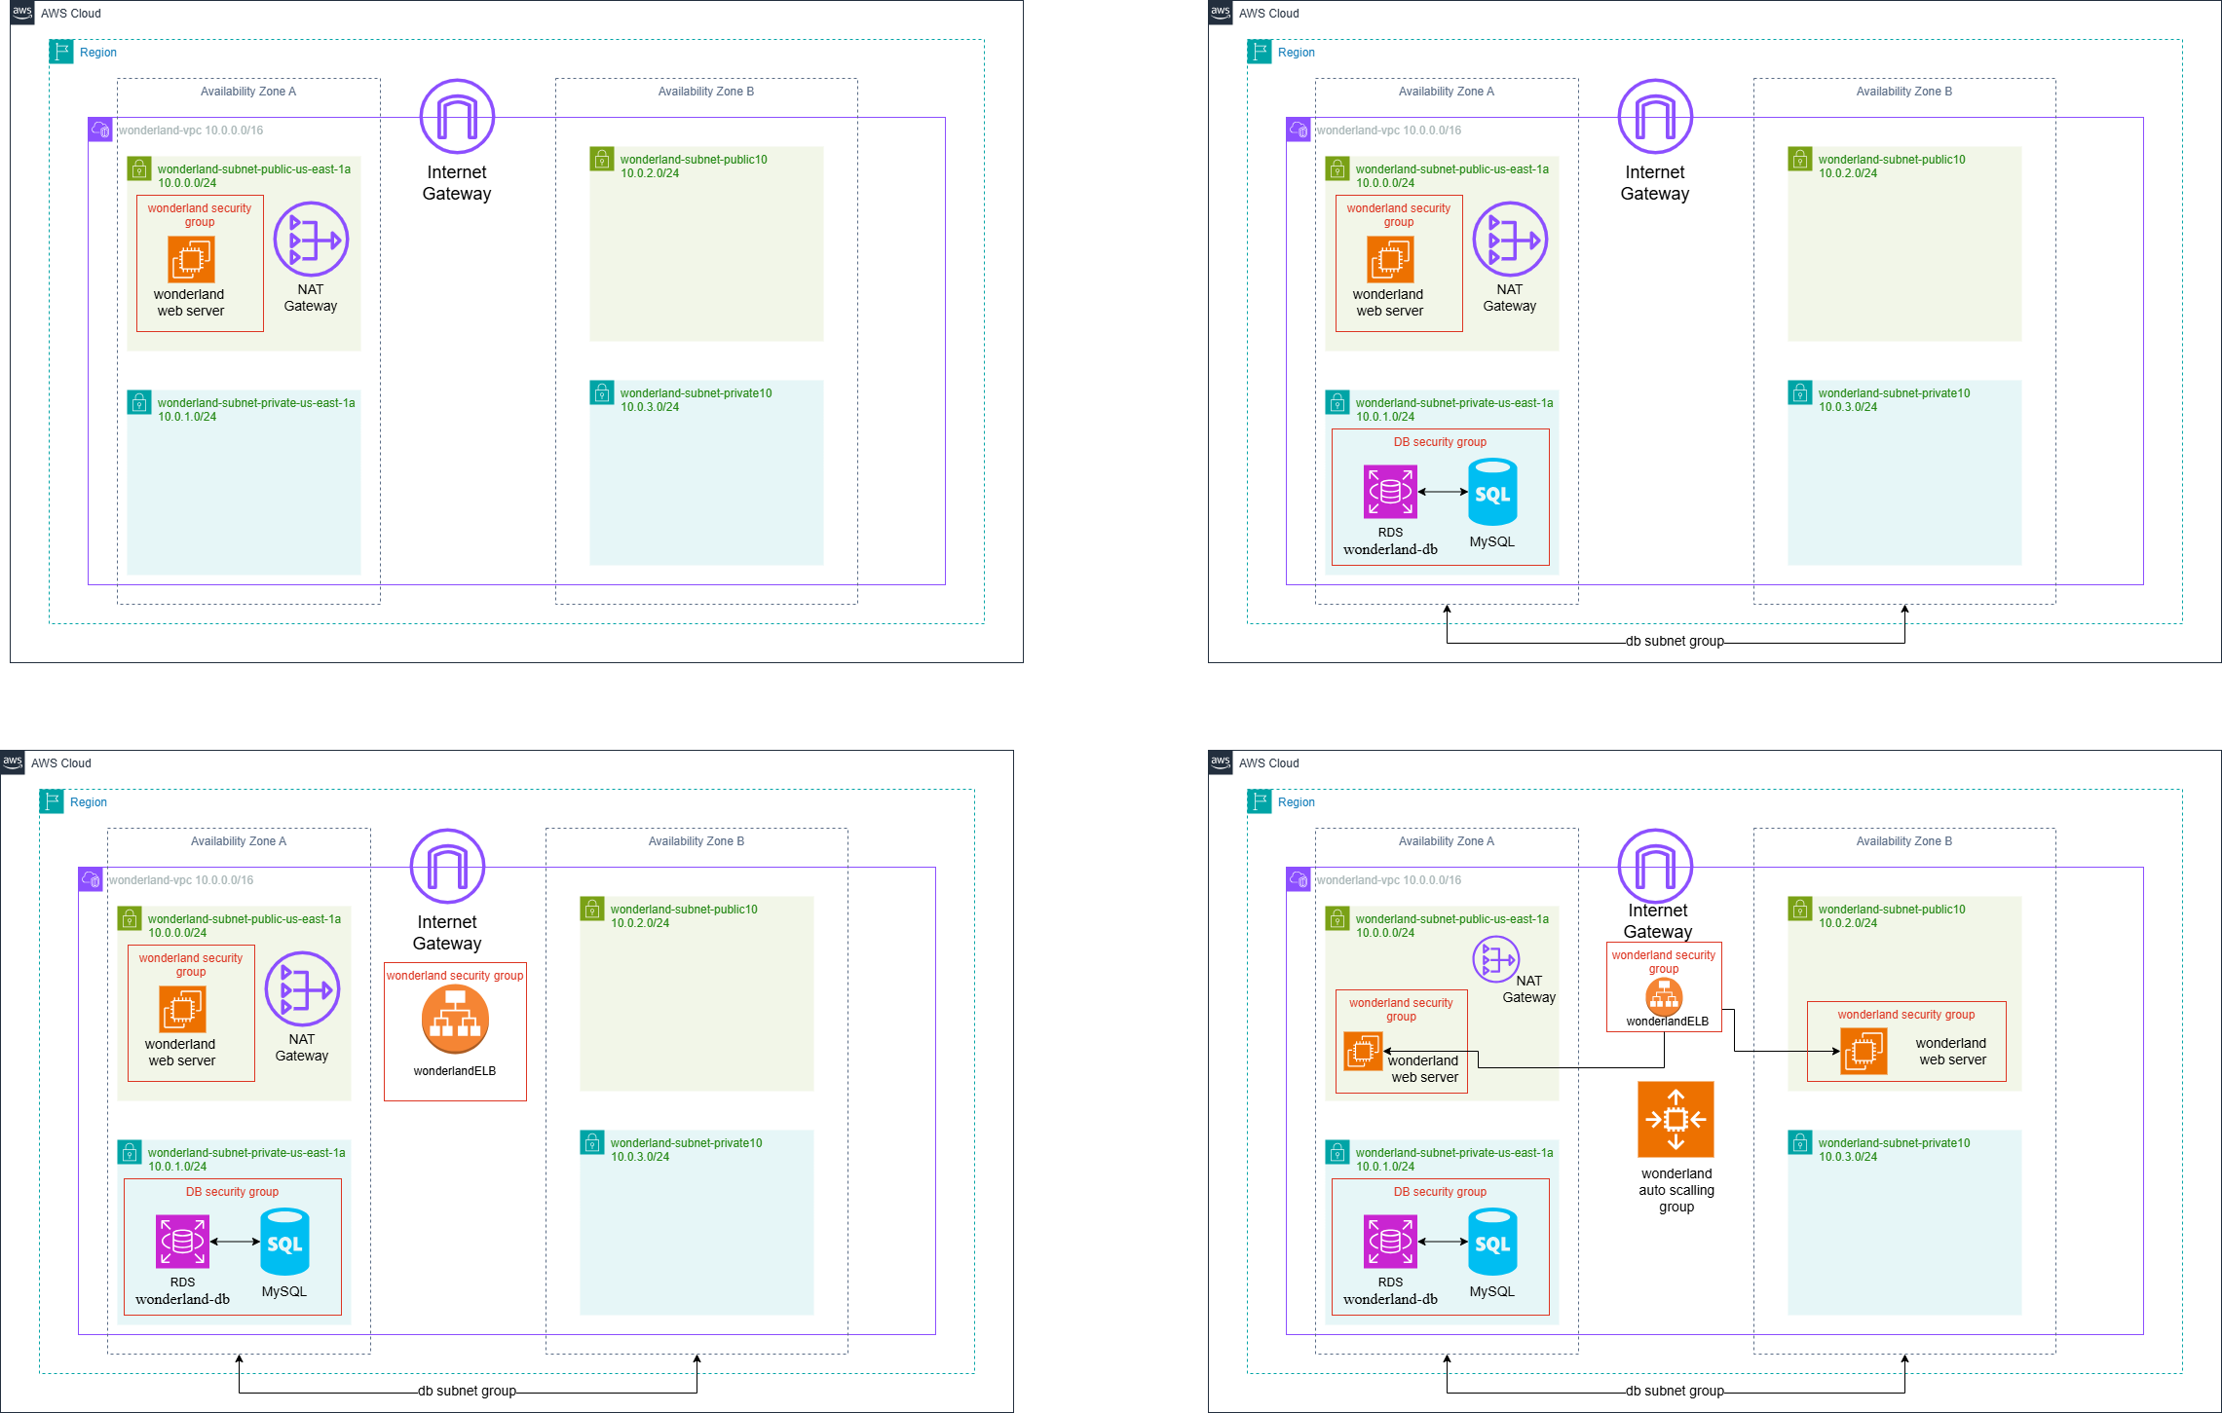

Figure 42 Phase 4 Layout Diagram of the Network

The final improved architecture of the Wonderland system as shown in figure 42 has Auto Scaling features, which ensure high availability, scalability, and fault tolerance. Based on the existing three-tier architecture, an Auto Scaling Group (ASG) is proposed to handle a number of EC2 instances in various Availability Zones in an automated fashion.

Application load balancer (ALB) remains the public point of entry of user requests. It spreads the traffic evenly among all the healthy EC2 instances registered in the target group. Multiple instances are spread across different Availability Zones instead of a single web server to remove single points of failure, and enhance service resilience.

The Auto Scaling Group is the dynamical increase or decrease of EC2 instances with the system demand. More are automatically launched during performance peak periods to preserve performance. On the contrary, when the usage is low, then the excess instances are killed in order to maximize cost efficiency. Moreover, the unhealthy cases are automatically substituted and the services are not disrupted.

The database tier is hosted on the Amazon RDS in private subnets and can only be accessed by the web servers. This multi-layered strategy is very strict in keeping the network isolated and more secure.

The system is horizontally scaled through the use of load balancing and auto scaling functions, which enhance the higher reliability and robustness of production. This is the last architecture, it is according to the AWS best practices of cloud architecture, and is applicable to actual enterprise deployment.

Step 1: **Creating the Amazon Machine Image (AMI)**

In Step 1, it is necessary to create a custom Amazon Machine Image (AMI) that will be used as the master template for the Auto Scaling Group. The software and configuration state necessary to meet the requirements of Phase 4 are captured by selecting the existing “wonderland web server” instance as the source. The image is then named “wonderlandAMI” to facilitate easy identification. The “Reboot instance” option is then selected to shut down the server temporarily, thus ensuring that the image created is data consistent and free of file corruption. This ensures that the system is able to generate a unique AMI ID, which is necessary to create pre-configured servers in response to increasing traffic needs.

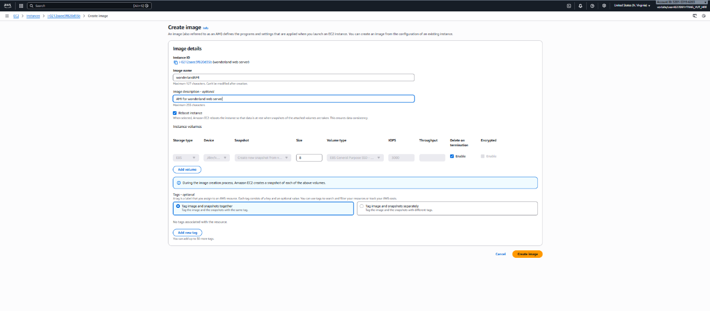

Figure 43 Create AMI

**Step 2: Launch Template Configuration**

Step 2 defines the Launch Template, which is a configuration wrapper that dictates to the Auto Scaling Group exactly how the new servers are to be provisioned. By giving the template the name wonderlandConfig and choosing the option 'Auto Scaling guidance,' the software is assured to be compatible with auto scaling features. The template combines the custom software developed in wonderlandAMI (from Step 1) with pre-specified hardware settings, including a t2.micro instance type and wonderland security group firewall settings. The result is a 'cookie cutter' template that ensures all new servers are identical, secure, and production-ready without requiring any configuration.

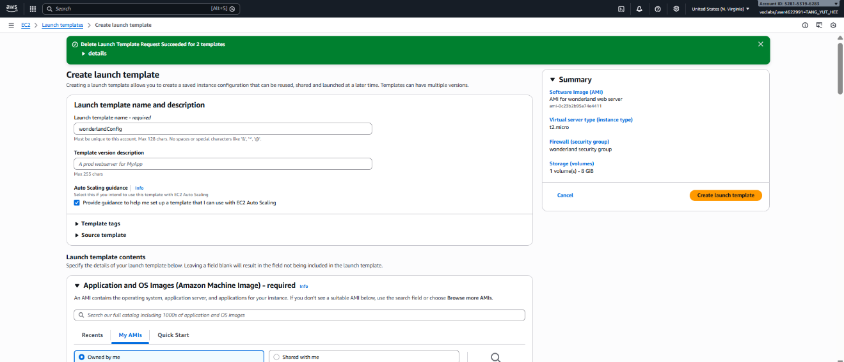

Figure 44 Create launch template

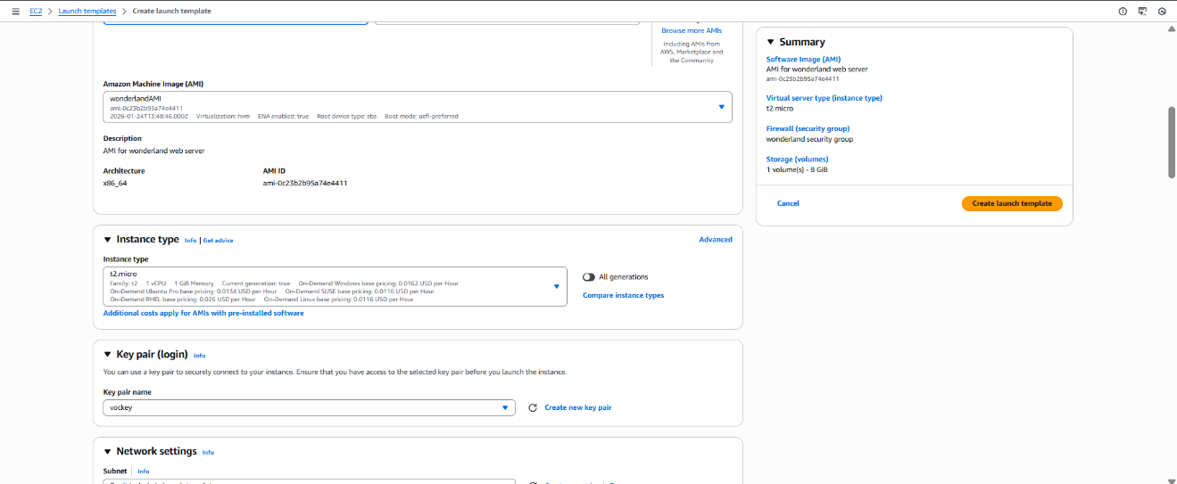

Figure 45 Instance type

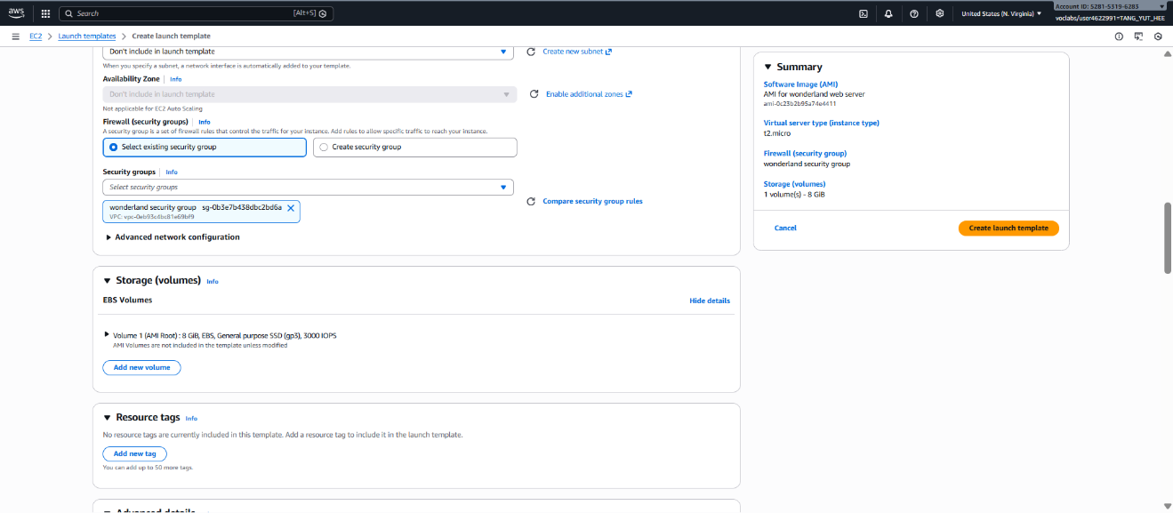

Figure 46 Wonderland Security Group Firewall Settings

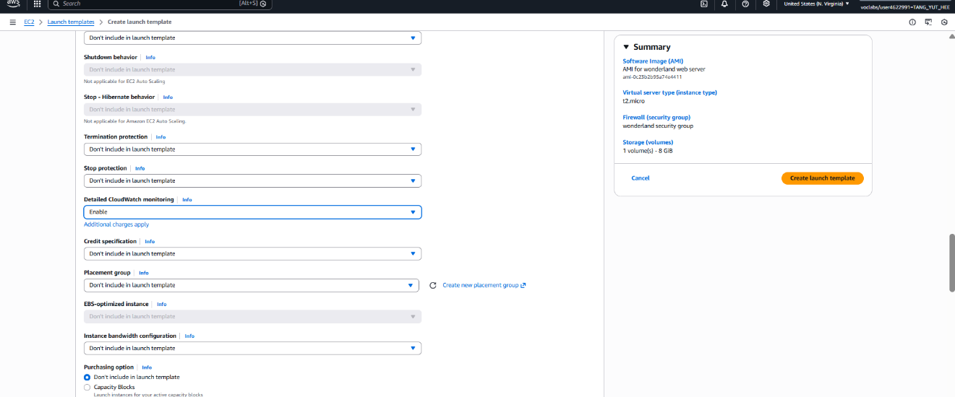

Figure 47 Enabling CloudWatch Monitoring

**Step 3: Auto Scaling Group (ASG) Deployment**

Step 1: Creation of the Custom AMI

This step requires the creation of a custom Amazon Machine Image that acts as the template or blueprint for the automated server creation process. In this process, the software configuration and state required in the next phase, i.e., Phase 4, are captured by using the existing “wonderland web server” instance as the source. The image is then named “wonderlandAMI” for easy identification. In addition, the “Reboot instance” feature is enabled in this step, which shuts down the server for a brief period, thus creating a data-consistent image that is not prone to file corruption.

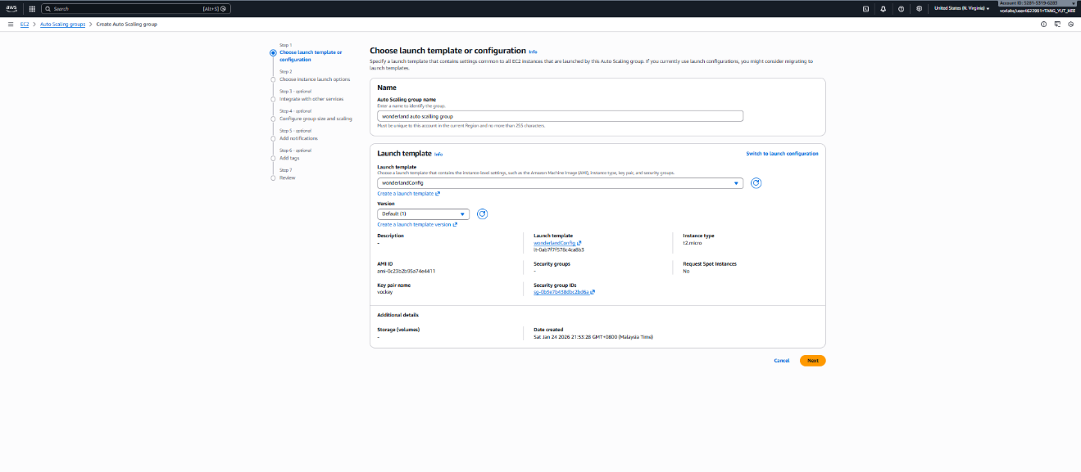

Figure 48 Creation of the Custom AMI

Step 2: Configuration of the Launch Template

This step involves the configuration of the Launch Template, which acts as a standard configuration template that guides the Auto Scaling Group in the creation of the server instances. In this process, the Launch Template is named wonderlandConfig, and the “Auto Scaling guidance” feature is enabled. This feature is essential in ensuring that the template is compatible with the automated scaling features. In this step, the software configuration created in the previous step is integrated with the hardware configuration, including the t2.micro instance type and the wonderland security group firewall rules, thus creating a production profile that acts as a “cookie cutter.”

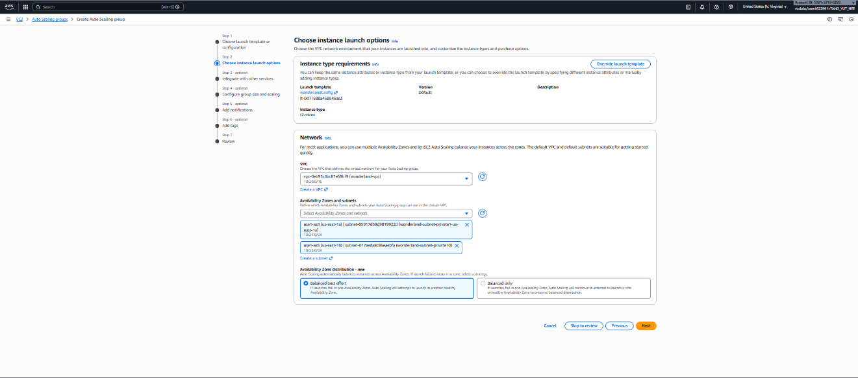

Figure 49 Configuration of the Launch Template

Step 3: Creation of the Auto Scaling Group (ASG)

This step involves the creation of the Auto Scaling Group, which is responsible for managing the lifecycle of the EC2 instances. In this process, the Launch Template wonderlandConfig is integrated with the Auto Scaling Group, with the network boundaries defined by the subnets in Availability Zone A and Availability Zone B, as shown in Figure 42. In addition, the Group Size parameters are defined in this step, including the minimum capacity required to ensure the continuous operation of the application and the maximum capacity required to limit the costs.

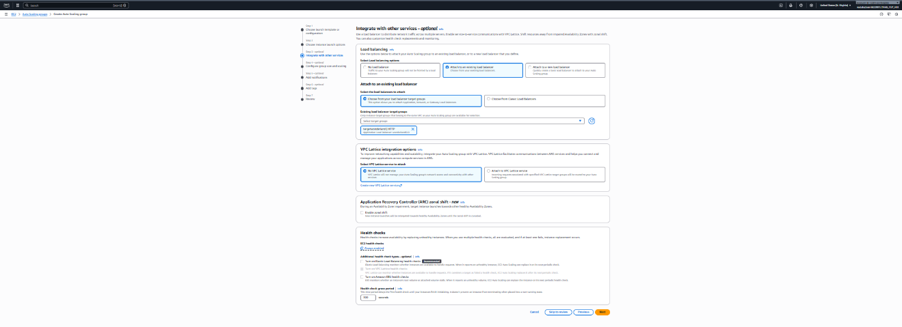

Figure 50 Creation of the Auto Scaling Group (ASG)

Step 4: Definition of Dynamic Scaling Policies

This step involves the definition of the policies that dictate the addition or removal of the servers. This is achieved by the implementation of the Target Tracking Scaling Policy, which is based on the CPU Utilization metric as described in the project context. For example, the target utilization is set at 50%, meaning that whenever the load is beyond this threshold, the ASG launches more instances (Scaling Out) to meet the increased demand. On the other hand, whenever the load is reduced, the instances are terminated (Scaling In) while keeping costs under control, as desired in Phase 4.

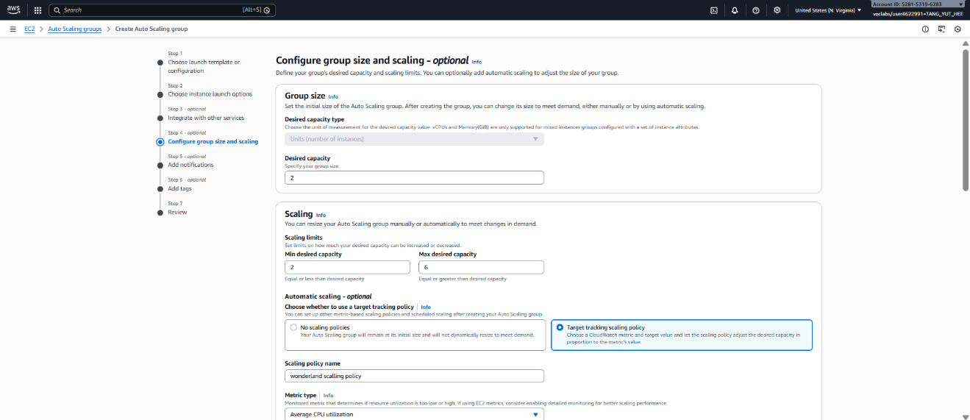

Figure 51 Definition of Dynamic Scaling Policies

Step 5: Adding Tags for Resource Identification

This section involves tagging the Auto Scaling Group, which will ensure that everything remains organized. The choice of Key = Name and Value = wonderland-TCC will provide a recognizable name to the Auto Scaling Group. The "Tag new instances" option is selected, which means that every new server that gets created through this group will be tagged with this name. This way, if there is a lot of traffic and the system needs to scale out, every new instance will be recognizable at once. 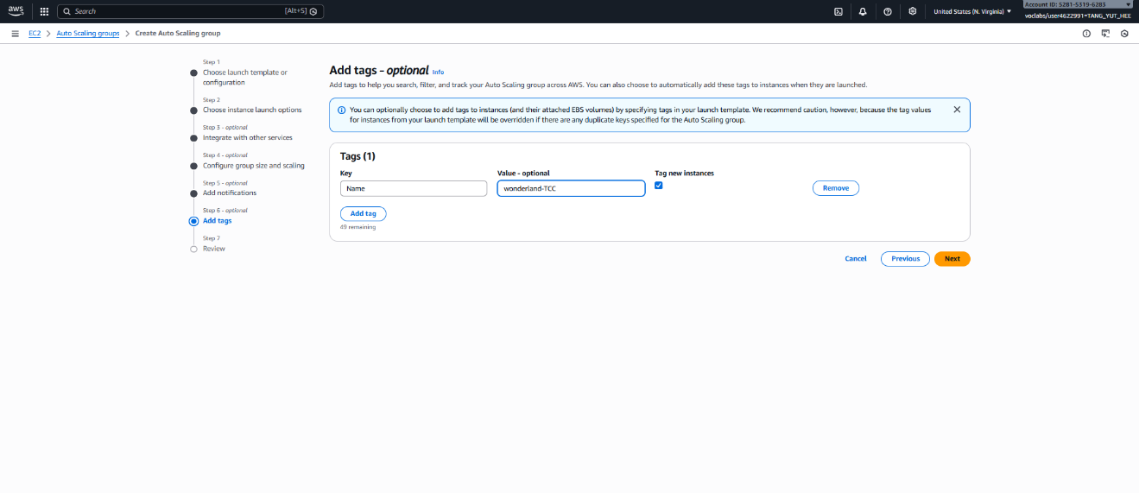

Figure 52 Add Tags

|  |  |
| --- | --- |
| **Auto Scaling group name** | wonderland_AS |
| **Launch template** | wonderlandConfig |
| **VPC** | wonderlandVPC-vpc |
| **Availability Zones and subnets** | wonderlandVPC-subnet-public1 |
| wonderlandWeb_subnet-public2 |
| **Load balancer target groups** | TargetKopiko |
| **Health checks** | Turn on Elastic Load Balancing health checks  (enable) |
| **Desired capacity** | 2 |
| **Min desired capacity** | 2 |
| **Max desired capacity** | 6 |
| **Automatic scaling** | Target tracking scaling policy: -  Scaling policy name: wonderlandScalingPolicy Metric type: Average CPU utilization  Target value: 60 |
| **Additional settings** | Enable group metrics collection within  CloudWatch |

Table 4 Configuration of ASG (wonderland_AS)

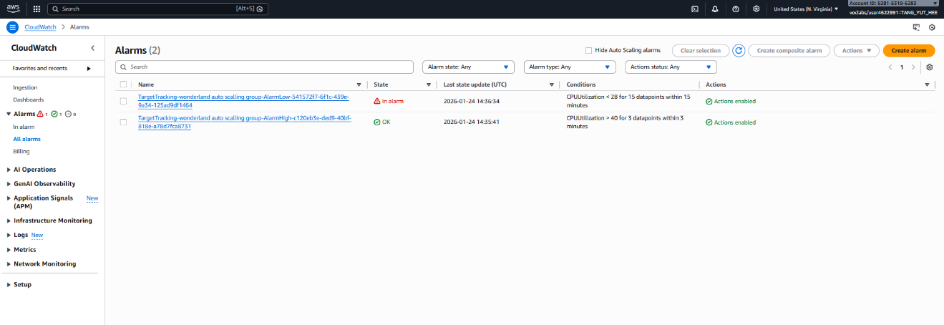

Figure 53 Alarm Dashboard

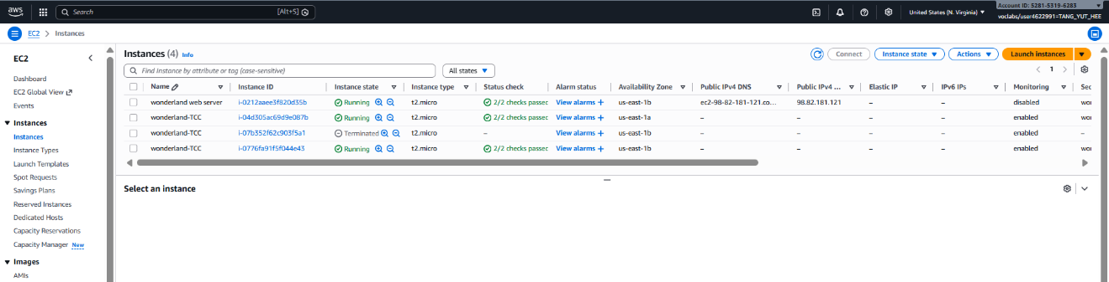

Figure 54 Instance Auto Scalling

# Reflection

This project provided our team with valuable practical experience in designing and deploying a cloud-based web application using AWS services. Across the four phases, the system evolved from a simple single-server setup into a scalable and highly available cloud architecture. Each phase introduced important concepts that strengthened our understanding of modern infrastructure design.

In **Phase 1**, we built a basic monolithic system using a single EC2 instance. By installing Apache, PHP, and MySQL on one server, we understood how traditional web hosting environments operate. At the same time, we recognized the limitations of this design, such as the risk of a single point of failure and the inability to scale easily.

In **Phase 2**, separating the database into Amazon RDS allowed us to implement a **2-tier architecture**. This significantly improved reliability and management because the database was now handled by AWS rather than running on the same machine as the web server. We learned how to migrate a database, modify application configuration files, and connect the web server to a managed database service. This phase highlighted the importance of separating system components to improve performance and fault tolerance.

In **Phase 3**, we introduced an **Application Load Balancer (ALB)**, transforming the design into a **3-tier architecture**. We learned how user traffic can be distributed through a load balancer before reaching the web server. This phase emphasized high availability, as the load balancer operates across multiple Availability Zones. We also gained practical knowledge about security groups, listeners, and target groups, and how they work together to correctly route traffic within AWS.

In **Phase 4**, we implemented **Auto Scaling**, which demonstrated how cloud systems can automatically adjust resources based on demand. We created launch templates, configured Auto Scaling Groups, and defined scaling policies using CPU utilization metrics. This phase helped us understand the flexibility of cloud computing and how systems can scale dynamically to maintain performance while optimizing costs.

Overall, this project strengthened our understanding of **cloud architecture, scalability, high availability, and fault-tolerant system design**. We gained hands-on experience with key AWS services including EC2, RDS, Elastic Load Balancer, and Auto Scaling. The gradual evolution of the system across the four phases helped us clearly understand how real-world cloud infrastructures are designed and deployed.

This project enhanced both our technical knowledge and our confidence in building reliable and scalable cloud-based systems in future work.

1. **Why did we move the database from EC2 to Amazon RDS?**

Initially, the database was hosted on the same EC2 instance as the web application (monolithic architecture). This approach is simple but risky because if the EC2 instance fails, both the application and the database become unavailable.

By migrating the database to Amazon RDS, **we achieved**:

* Better reliability, RDS provides managed backups and maintenance
* Improved security, Database can be placed in a private subnet
* Performance optimization, Database and application resources are separated
* Scalability, Database can be upgraded independently from the web server

This transformation converted the system from a single-point-of-failure design to a more stable two-tier architecture.

1. **Why was an Elastic Load Balancer (ELB) introduced?**

After separating the database, the next improvement was to make the application highly available. An Elastic Load Balancer was added to:

* Distribute incoming traffic across multiple EC2 instances
* Prevent overloading a single server
* Improve system availability if one instance fails
* Provide a single public DNS endpoint for users

This step transformed the system into a three-tier architecture and removed dependency on a single application server.

1. **What problem does Auto Scaling solve?**

Auto Scaling ensures the system can handle traffic changes automatically.

Without Auto Scaling:

* One server might become overloaded during high traffic
* Resources may be wasted during low traffic

With Auto Scaling:

* New EC2 instances are automatically added when demand increases
* Instances are removed when demand decreases
* The system maintains performance while optimizing cost

This allows the architecture to be elastic, which is a core benefit of cloud computing.

4. What is the difference between monolithic and multi-tier architecture?

|  |  |
| --- | --- |
| **Monolithic Architecture** | **Multi-Tier Architecture** |
| All components run on one server | Components are separated (web, app, database) |
| Simple to build | More complex but more scalable |
| High risk of total failure | Failure in one layer does not stop entire system |
| Hard to scale | Each tier can scale independently |

Our project evolved from a monolithic system (Phase 1) to a scalable multi-tier cloud architecture (Phase 4) following cloud best practices.

1. **What AWS Well-Architected principles were applied in this project?**

The final architecture aligns with AWS cloud best practices:

* **Reliability,** Load balancing and RDS backups
* **Performance Efficiency,** Separate compute and database resources
* **Scalability**, Auto Scaling groups
* **Security**, Security groups and controlled network access
* **Cost Optimization**, Scaling resources based on demand

1. **Conclusion**

Through the four implementation phases, the system evolved from a basic single-server deployment into a resilient, scalable, and production-style cloud architecture, demonstrating practical understanding of real-world cloud design principles.

# References

* *Configuring an Amazon RDS DB instance - Amazon Relational Database Service*. (n.d.). <https://docs.aws.amazon.com/AmazonRDS/latest/UserGuide/CHAP_RDS_Configuring.html>
* *Getting Started with Auto Scaling*. (n.d.). Amazon Web Services, Inc. https://aws.amazon.com/autoscaling/getting-started/
* *Create an application load balancer - elastic Load balancing*. (n.d.). https://docs.aws.amazon.com/elasticloadbalancing/latest/application/create-application-load-balancer.html

# Appendices

#!/bin/bash

dnf update -y

dnf install -y httpd php php-mysqlnd git mariadb105-server

systemctl start httpd

systemctl enable httpd

systemctl start mariadb

systemctl enable mariadb

cd /var/www/html

rm -f index.html

git clone https://github.com/yx051128/ec2-website.git

cp -r ec2-website/direct/* /var/www/html/

mysql -u root <<EOF

CREATE DATABASE IF NOT EXISTS tccwonderland CHARACTER SET utf8mb4;

CREATE USER IF NOT EXISTS 'phpuser'@'localhost' IDENTIFIED BY '';

GRANT ALL PRIVILEGES ON tccwonderland.* TO 'phpuser'@'localhost';

FLUSH PRIVILEGES;

USE tccwonderland;

SOURCE /var/www/html/db.sql;

EOF

chown -R apache:apache /var/www/html

chmod -R 755 /var/www/html

systemctl restart httpd